Daily Transdermal Patch Application Record Chart

When using this chart, write ‘see DAILY Transdermal Patch Application Record Chart’ on main MAR.
DO NOT DOUBLE RECORD
Resident Name: |  | Date of Birth:
Drug/strength: |  | Frequency of application:
Details completed by: |  | Details checked by:
Special Instructions:
- The old patch should be removed before applying the new patch. The old patch must be folded in half and stuck together before disposal, in accordance with the care home policy.
- The site of application should be rotated in accordance with the manufacturer guidance (please see table below for a guide).
- Use a cross (x) to indicate where the new patch has been applied (this must be a cool, clean, dry, non-hairy area of the body where either a visiting child or in some cases the resident cannot reach).
- Heat can increase the absorption of some medicines through the skin into the bloodstream. You should not apply a patch immediately after a person has had a bath or shower. People should also avoid soaking in a hot bath or using a sauna when using a patch.
 | Fentanyl | Butrans/Butec (buprenorphine) | Transtec (buprenorphine) | Hyoscine | Rivastigmine | Rotigotine
Duration of use | 72 hours | 1 week | 4 days | 72 hours | 24 hours | 24 hours
Number of sites on rotation | 3 sites | 4 sites | 2 sites | 2 sites | 14 sites | 14 sites
Interval before reusing a site | 1 week | 3-4 weeks | 1 week | 72 hours | 14 days | 14 days

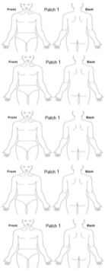
Day 1 | Date | Time | Signed
Applied
Removed
Day 2 | Date | Time | Signed
Applied
Removed
Day 3 | Date | Time | Signed
Applied
Removed
Day 4 | Date | Time | Signed
Applied
Removed
Day 5 | Date | Time | Signed
Applied
Removed
Day 6 | Date | Time | Signed
Applied
Removed
Day 7 | Date | Time | Signed
Applied
Removed
Day 8 | Date | Time | Signed
Applied
Removed
Day 9 | Date | Time | Signed
Applied
Removed
Day 10 | Date | Time | Signed
Applied
Removed

Please turn over for further application site information Days 11 - 28

DAILY Transdermal Patch Application Record Chart (continued)
Resident Name: | Date of Birth:
Drug/strength: | Frequency of application:

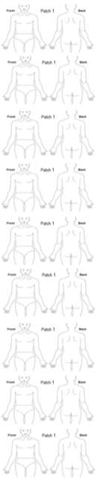
Day 11 | Date | Time | Signed
Applied
Removed
Day 12 | Date | Time | Signed
Applied
Removed
Day 13 | Date | Time | Signed
Applied
Removed
Day 14 | Date | Time | Signed
Applied
Removed
Day 15 | Date | Time | Signed
Applied
Removed
Day 16 | Date | Time | Signed
Applied
Removed
Day 17 | Date | Time | Signed
Applied
Removed
Day 18 | Date | Time | Signed
Applied
Removed
Day 19 | Date | Time | Signed
Applied
Removed
Day 20 | Date | Time | Signed
Applied
Removed
Day 21 | Date | Time | Signed
Applied
Removed
Day 22 | Date | Time | Signed
Applied
Removed
Day 23 | Date | Time | Signed
Applied
Removed
Day 24 | Date | Time | Signed
Applied
Removed
Day 25 | Date | Time | Signed
Applied
Removed
Day 26 | Date | Time | Signed
Applied
Removed
Day 27 | Date | Time | Signed
Applied
Removed
Day 28 | Date | Time | Signed
Applied
Removed

Comments:

