Appendix 2: SystmOne Searches to Support Prescribing Incentive Scheme 23/24
Review of Glucagon-like peptide-1 agonists (GLP-1 RA) as response to national shortages and MSN 28.6.23

Step 1: Identify and run the relevant supporting searches
SystmOne search can be found: Reporting → Clinical Reporting → BSW General Practice → Medicines Optimisation Team → GLP-1 searches:
A set of locally developed SystmOne searches have been developed to support practice reviewing patients who are on GLP-1 RA as response to national shortage:
- A: Number of patients on GLP-1 RA but without T2 DM read code
- B: Number of patients with T2 DM coded, on GLP-1 RA AND established on insulin
- C1: Number of patients with T2 DM coded, on GLP-1 RA, not on insulin last Hba1c > 86 mmol/mol
- C2: Number of patients with T2 DM coded, on GLP-1 RA, not on insulin last Hba1c 58-86 mmol/mol
- C3: Number of patients with T2 DM coded, on GLP-1 RA, not on insulin last Hba1c < 58 mmol/mol

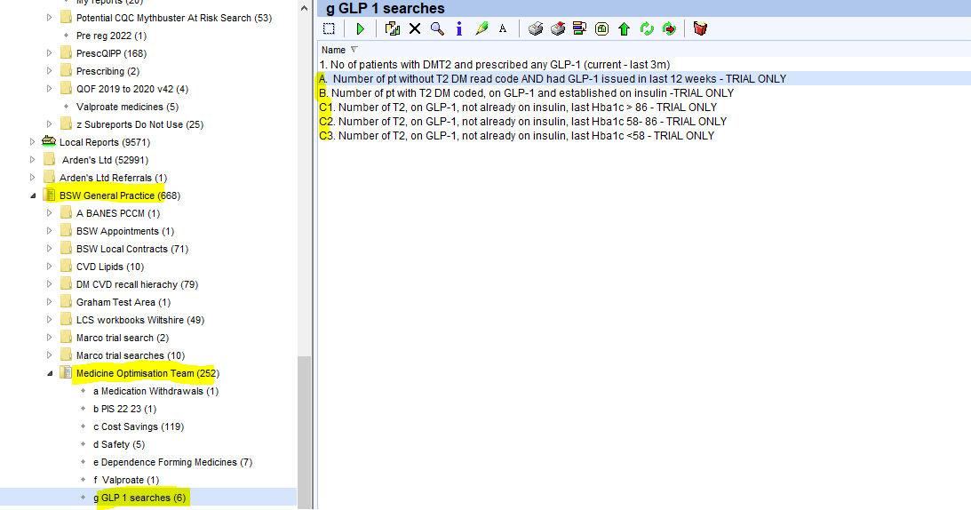

Step 2: Selecting relevant supplementary information:

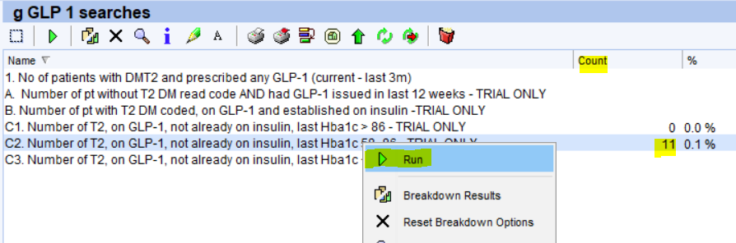
Selecting the search that you would like to run, right click and click ‘Run’

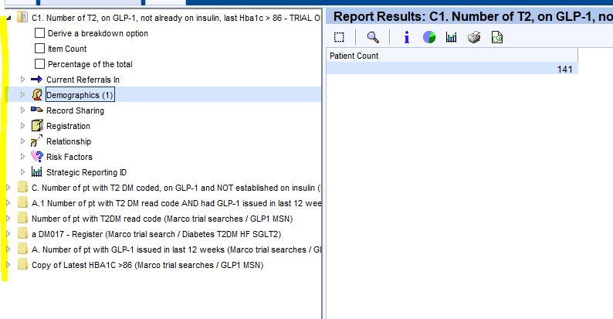

A list of supplementary information such as demographics, patient’s details, NHS number, last recorded Hba1c value, GLP-1 RA drug etc. can be obtained by clicking the relevant boxes on the left-hand side column as highlighted.

For example: By clicking the relevant subtitle and tick the supplementary information that you would require.
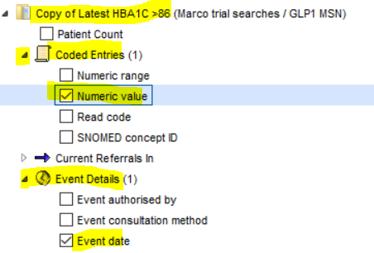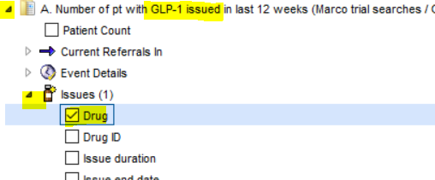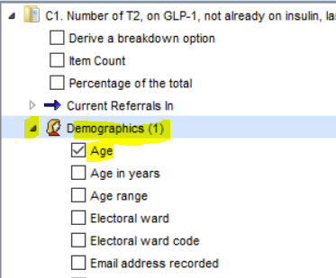

Step 3: Extract data

Click ‘Refresh’ and the search result should be displayed in column like picture below. Click ‘CSV button’ to export the relevant data into CSV/Excel* format.
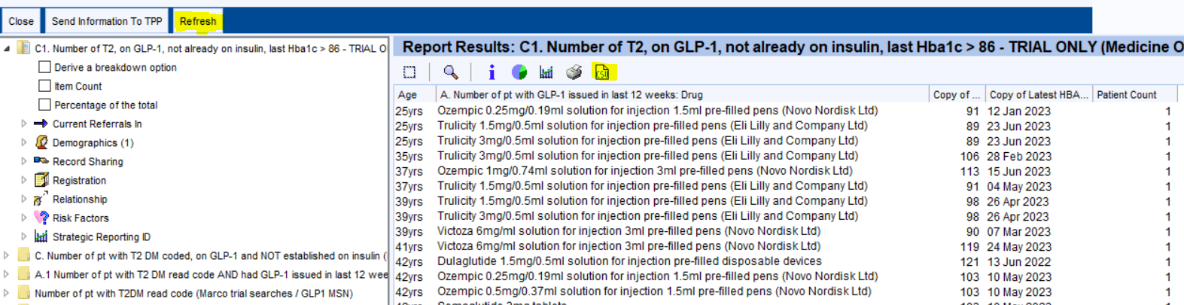

*Consider custom sort, drug type, Hba1c value or/and last Hba1c blood test event date in the Excel spreadsheet to facilitate prioritisation of review.

Additional Resources:
Additional Resources:

BSW TPP local template
Local template has been developed to support practices reviewing patient on GLP-1 RA in response to the MSN and Prescribing incentive scheme 23/24. The template can be located by entering ‘BSW ICB GLP-1 review template’ at the ‘Search features’ bar.

Type 2 diabetes structured education
NHS England Healthy Living free online service to help people with type 2 diabetes better manage their condition. Patient leaflet and further resources can be found: here

Further local and national resources to support practices will be uploaded here Stock Shortages - Medicines (bswtogether.org.uk)

