Winter 23/24
Children’s self-care

Communications Toolkit
Version 1.0
This toolkit is designed to support BSW wide communications in the dissemination of consistent key messages and assets across all of our shared audiences to maximise our reach and engagement with our target audiences.

CAMPAIGN AIMS

- Educate parents and carers on how to handle common childhood illnesses
- Support appropriate NHS service use
- Disseminate supportive content to coincide with increasing presentations to NHS services at the start of winter

SOCIAL MEDIA ASSETS - All Audiences

Assets and suggested copy available to download from the BSW Together Campaigns Page at www.bswtogether.org.uk/yourhealth/campaigns

For Instagram, make sure you have the appropriate link in your bio: https://www.nhs.uk/conditions/baby/health/looking-after-a-sick-child/

 | Facebook | Instagram | Twitter
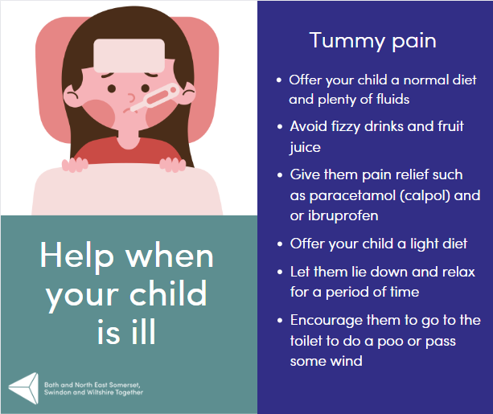 | Tummy pain is very common in children but can be worrying. Most children will not need any specific treatment and the pain will get better by itself.  What Should You Do If Your Child Has Tummy Pain?  If your child has tummy pain there are a few things you can do to below to help them;  Offer your child a normal diet and plenty of fluids. Avoid fizzy drinks and fruit juices.  Give them pain relief such as paracetamol (calpol) and or ibuprofen. Always read the labels on the bottle, and never give more than the recommended dose for age.  Offer your child bland foods.  Let them lie down and relax for a period of time.  Encourage them to go to the toilet to do a poo or pass some wind.  If your child also has runny poos (diarrhoea), offer small amounts of fluid often to try and avoid them getting dehydrated.  If their pain is not controlled with simple pain relief, if they develop jaundice (yellow skin or eyes), have a swollen tummy, are weeing more or less than usual or have blood in their poo or wee, you should arrange for them to be seen urgently by a medical practitioner. Call your GP surgery or NHS 111. | Tummy pain in kids is common but worrisome. Most times, it resolves on its own. Here's what to do if your child has tummy pain:  1️. Offer a normal diet and fluids (avoid fizzy drinks and fruit juices).  2. Provide pain relief like paracetamol or ibuprofen (follow age-appropriate dosages).  3. Give bland foods.  4. Let them rest.  5. Encourage a visit to the toilet.  If they have diarrhoea, offer small fluid amounts to prevent dehydration. Seek urgent medical attention if pain persists, or if they show concerning symptoms like jaundice, swollen tummy, unusual urination, or blood in their poo or wee.  For more guidance, visit the NHS website (link in bio). If you're concerned about worsening symptoms, call 111. #ChildHealth #TummyTroubles #NHSAdvice | Tummy pain in kids is common but often resolves. Offer fluids, pain relief, and rest. Get more child health info on the NHS website.  #ChildHealth #NHSAdvice
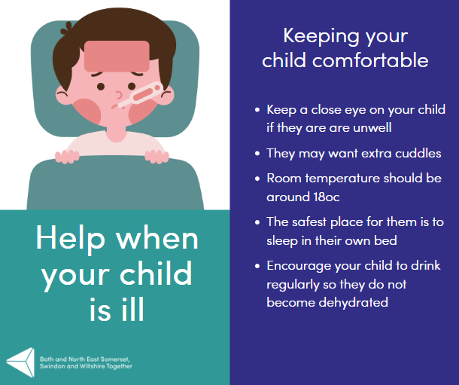 | When children are poorly they don’t want to be alone. They may want to be with you during the day and may want extra cuddles. Remember, the safest place for them to sleep is in their own bed. If they are struggling to settle, set up a bed next to their cot or moses basket and sleep next to them.  Avoid having the room too warm, especially if your child has a raised temperature. Room temperature should be around 18 degrees and preferably draught free. Keep your child dressed in comfortable clothing.  Encourage your child to drink regularly so they do not become dehydrated. If they are breast-fed they may want to feed more often. Seek medical advice if they can’t keep fluids down.  If you are worried that their symptoms are getting worse call 111 for advice. | When kids are unwell, they seek comfort. Be there for them during the day, offer extra cuddles. Ensure they sleep in their own bed, but set up a nearby bed if needed. Maintain a comfortable room temperature, around 18°C, and dress them comfortably.  Keep them hydrated with regular drinks, and if breastfed, offer more feeds if desired. Seek medical advice if fluids are a concern.  For more guidance, visit the NHS website (link in bio). If you're concerned about worsening symptoms, call 111. 🩺💙 #ChildHealth #CaringForSickChild #NHSAdvice | When kids are unwell, they need comfort. Keep them hydrated and seek medical advice if needed. Get more child health info on the NHS website.  #ChildHealth #NHSAdvice
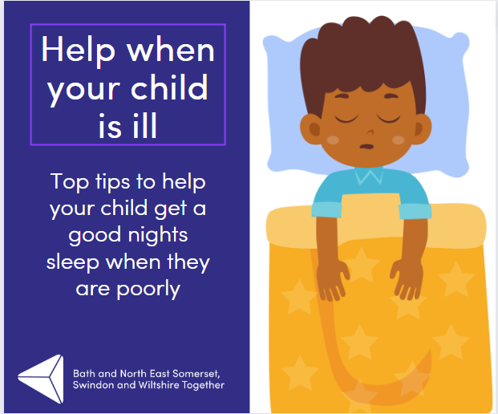 | Coughs that can come along with a cold, can cause sleepless nights for all. Try these tips to help your child get a better night's sleep.  - If your child is under 1 year old - try propping up the legs of the cot at the head end on a couple of big books. This can help any irritating secretions drain away.  - If your child is older than 1 - you can try an extra pillow to prop them up.  - Have a drink close by.  - Use Vaseline on sore noses and lips.  - If your child has a pre-existing condition, like asthma, keep giving any prescribed medication.  For more information on children’s illnesses, where to get help, and what you can do to help them at home visit the NHS website for more advice.  If you are worried that their symptoms are getting worse call 111 for advice. | Coughs during a cold can disrupt sleep. Try these tips for a restful night:  - Under 1: Elevate cot legs with books.  - Over 1: Use an extra pillow.  - Keep a drink nearby.  - Apply Vaseline for sore noses and lips.  - Maintain prescribed medication for pre-existing conditions like asthma.  For more child health advice, visit the NHS website (link in bio). If symptoms worsen, call 111. 🩺💙 #ChildHealth #SleepTips #NHSAdvice | Coughs during colds can disrupt sleep. Elevate cot legs, use an extra pillow, and keep a drink nearby. Vaseline also helps soothe. #ChildHealth #SleepTips
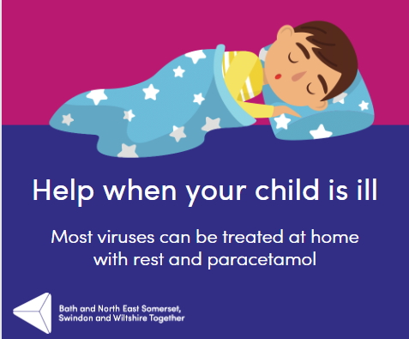 | Most minor childhood illnesses are caused by viruses so antibiotics may not help. There is a lot you can do at home to help your child to feel better.  Babies and very young children can’t always tell you what is wrong but they may become irritable, they may cry more than usual, or they may be unusually quiet. Their sleep pattern and appetite might be different from what is usual for them.  Offer small healthy snacks and regular drinks, or if your baby or young child is breastfeeding, continue to offer to breastfeed regularly as this will help to stop them from becoming dehydrated.  For more information on children’s illnesses, where to get help, and what you can do to help them at home visit the NHS website for more advice.  If you are worried that their symptoms are getting worse call 111 for advice. | When kids are unwell, it's often viral, so antibiotics may not help. You can do a lot at home to comfort them. Babies can't express their discomfort, but if they're irritable, cry more, or sleep differently, offer healthy snacks and fluids. Breastfeeding helps prevent dehydration.  For more child health advice, visit the NHS website (link in bio). If you're concerned about worsening symptoms, call 111. 🩺💙 #ChildHealth #HomeCare #NHSAdvice | Most childhood illnesses are viral, so antibiotics may not help. Comfort them with snacks, fluids, and love. Get more child health info on the NHS website.  . If symptoms worsen, call 111. #ChildHealth #NHSAdvice
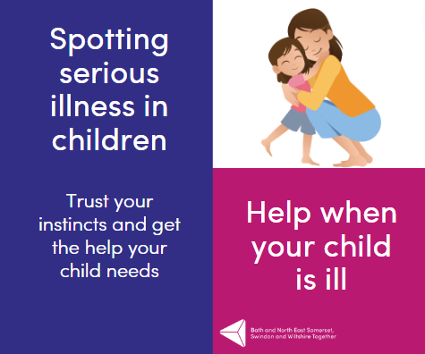 | Spotting Serious Illness in Children  Remember: It is important you trust your instincts and get the help your child needs. Not getting the advice and treatment at the right time could put your child at risk of serious illness.  If your child already has a health condition (like asthma, diabetes, epilepsy) look out for warning signs that their condition is less well controlled. Follow the advice given to you by the medical team that looks after your child.  For more information on children’s illnesses, where to get help, and what you can do to help them at home visit the NHS website for more advice.  If you are worried that their symptoms are getting worse call 111 for advice. | Spotting Serious Illness in Children: Trust your instincts. Prompt advice and treatment are crucial to safeguard your child's health. If they have an existing condition, watch for signs of worsening control. Follow medical advice diligently. For more guidance, visit the NHS website (link in bio). #ChildHealth #StayVigilant #NHSAdvice | Spotting Serious Illness in Children: Trust your instincts! Timely care is vital for your child's well-being. If they have a pre-existing condition, monitor for any worsening signs. Follow medical advice. Get more child health info on the NHS website  #ChildHealth #StayAlert #NHSAdvice
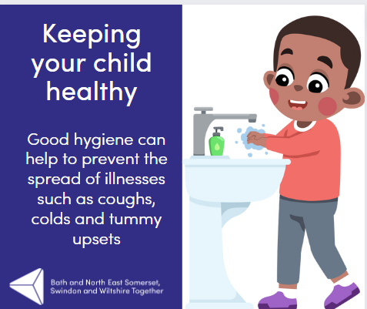 | It is important thing is to teach your child to always wash their hands well, using hot water and soap, using a tissue to catch coughs and sneezes, and keeping away from others when feeling unwell. This will help to reduce the risk of picking up, or spreading, infections.  Some illnesses such as coughs and colds can spread from one person to another very easily. There are some simple things that you can do to reduce the risk of this happening.  🧴 Wash your hands using hot water and soap regularly. Make sure children do the same.  🤧 Use a tissue when you blow your nose, cough or sneeze then throw it away and wash your hands afterwards.  🥤 Don’t share towels, cups or drinks bottles especially with anyone who is unwell.  🚽 Keep surfaces where food is prepared clean. Keep bathrooms and toilets clean.  🫧 Touch as few surfaces as possible when you are out and about and wash your hands when you get home.  If you are unwell try and avoid close contact with others who may be more sensitive to illnesses like the very young, the elderly or those who have other health problems.  For more information on children’s illnesses, where to get help, and what you can do to help them at home visit the NHS website for more advice. | Teaching good hygiene habits to your child is essential in reducing the risk of infections. Here's how to keep those germs at bay:  1️. Wash hands with hot water and soap, and teach kids to do the same.  2️. Use tissues for coughs and sneezes, then dispose of them and wash hands.  3️. Avoid sharing towels, cups, or bottles, especially with the unwell.  4️. Keep food preparation surfaces, bathrooms, and toilets clean.  5️. Minimize touching surfaces when outside and wash hands upon returning home.  When unwell, avoid close contact with those more vulnerable, like the young, elderly, or those with health issues.  Stay informed and stay healthy! For more advice, visit the NHS website (link in bio).  #HygieneMatters #InfectionPrevention #NHSAdvice | Teaching kids good hygiene is crucial. Reduce infections with handwashing, tissue use, and cleanliness. #HygieneMatters
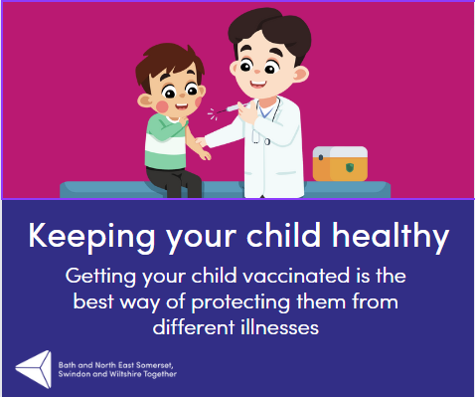 | Since the start of the COVID-19 pandemic, there has been a drop in uptake levels of children getting their routine vaccines. It’s never too late for children to catch up on their childhood vaccines, even if they have missed them in the past, or you are unsure about your child’s vaccination history.  Vaccinations are safe and sometimes can get rid of a disease totally.  Vaccines teach your immune system how to create antibodies that protect you from diseases.  It's much safer for your immune system to learn this through vaccination than by catching the diseases and treating them.  Once your immune system knows how to fight a disease, it can often protect you for many years.  Babies have their first vaccinations at 8 weeks, then they have them every four weeks until they are 16 weeks old. It’s safe to give babies and children several vaccines at a time.  For more information about baby and childhood immunisations, please visit https://www.nhs.uk/conditions/vaccinations/nhs-vaccinations-and-when-to-have-them/ | Vaccinations are safe and crucial for disease prevention.  - Vaccines teach your immune system to fight diseases.  - Safer than catching diseases.  - Protects for years.  - Babies start at 8 weeks.  Keep your child safe. For more advice, visit the NHS website (link in bio).  #ChildVaccines #StayProtected #HealthyKids | Vaccinations are safe and vital for disease prevention.  🦠 They teach your immune system to fight diseases.  🦠 Safer than getting sick.  🦠 Protection for years.  🦠 Babies start at 8 weeks.  Keep your child safe. Learn more: https://www.nhs.uk/conditions/vaccinations/ #ChildVaccines #StayProtected #HealthyKids
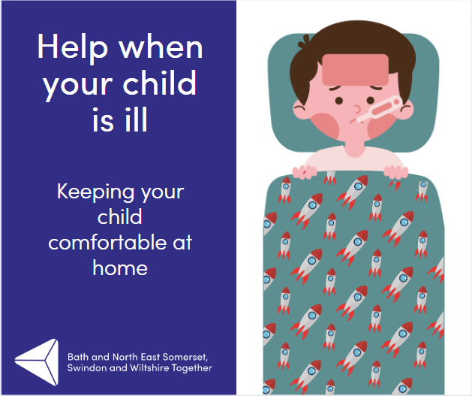 | When children are poorly they don’t want to be alone. They may want to be with you during the day and may want extra cuddles. Remember, the safest place for them to sleep is in their own bed. If they are struggling to settle, set up a bed next to their cot or moses basket and sleep next to them.  Avoid having the room too warm, especially if your child has a raised temperature. Room temperature should be around 18 degrees and preferably draught free. Keep your child dressed in comfortable clothing.  Encourage your child to drink regularly so they do not become dehydrated. If they are breast-fed they may want to feed more often. Seek medical advice if they can’t keep fluids down.  For more information on children’s illnesses, where to get help, and what you can do to help them at home visit the NHS website for more advice.  If you are worried that their symptoms are getting worse call 111 for advice. | 🤒 When our little ones are feeling under the weather, they need extra love and care. Here are some tips to help you look after a sick child:  1️⃣ Keep them company: Sick kids often crave your presence. Spend time with them during the day, offering extra cuddles and comfort.  2️⃣ Safe sleep: Make sure they sleep in their own bed. If they're having trouble settling, set up a bed next to their cot or Moses basket and sleep nearby.  3️⃣ Comfortable environment: Maintain a room temperature of around 18°C, avoiding excessive warmth, especially if they have a fever. Ensure the room is draught-free and dress them in comfortable clothing.  4️⃣ Stay hydrated: Encourage them to drink regularly to prevent dehydration. If they're breastfed, they may want to feed more frequently. Seek medical advice if they struggle to keep fluids down.  For more guidance on caring for a sick child, visit the NHS website (link in bio). 💙🏥 #ChildCare #SickChild #ParentingTips #NHSAdvice | When kids are sick, offer extra love and care. Keep them comfortable and hydrated and try to ensure they get enough sleep. Get more child health info on the NHS website.  💙🏥 #ChildCare #NHSAdvice
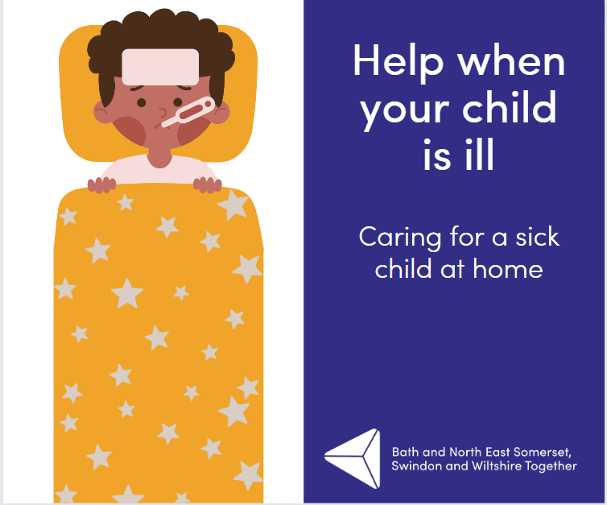 | Most minor childhood illnesses are caused by viruses so antibiotics may not help. There is a lot you can do at home to help your child to feel better.  Babies and very young children can’t always tell you what is wrong but they may become irritable, they may cry more than usual, or they may be unusually quiet. Their sleep pattern and appetite might be different from what is usual for them.  Offer small healthy snacks and regular drinks, or if your baby or young child is breastfeeding, continue to offer breastfeeds regularly as this will help to stop them from becoming dehydrated.  For more information on children’s illnesses, where to get help, and what you can do to help them at home visit the NHS website for more advice.  If you are worried that their symptoms are getting worse call 111 for advice. | Quick Tips to Help Your Little One Feel Better from Home!  Most childhood illnesses are caused by viruses, so antibiotics may not be effective. But don't worry, you can still make a big difference in your child's well-being right at home!  It can be tough when babies and young children can't express what's wrong, but watch out for signs like irritability, excessive crying, or unusual quietness. Keep an eye on changes in their sleep patterns and appetite too.  Provide small, healthy snacks and regular drinks to keep them nourished. For breastfeeding babies, continue offering breastfeeds to prevent dehydration.  Check out the NHS website for more expert guidance on caring for a sick child: Link in bio  If you ever feel concerned about your child's worsening symptoms, don't hesitate to call 111 for professional advice.  Remember, your love and care can work wonders! Stay strong, parents!  #ChildhoodIllnesses #HomeRemedies #ParentingTips #NHSguidance #SickChildCare | Help your child feel better at home. Look for changes in behaviour, offer snacks, and stay hydrated. Get more child health info on the NHS website  🌡️👨‍⚕️ #ChildHealth #HomeCare #NHSAdvice
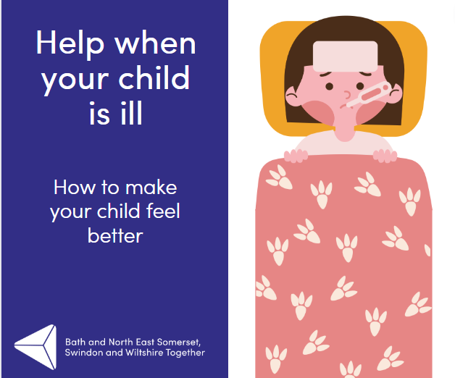 | Whilst a cold has to run its course, there are things you can do to help your child feel better.  - Take time for cuddles. You might find your child wants you extra close for comfort.  - Make sure that your child drinks plenty of fluids to keep hydrated. (Don’t worry if they don’t feel very hungry for a few days).  - Warm baths and warm drinks can help stuffy noses and be relaxing before bed.  - Give children’s paracetamol or ibuprofen. You can talk to your pharmacist about this.  - Try saline nose drops or sprays to help your child breathe more easily – ask your pharmacist for details.  Get more child health info on the NHS website.  If you are worried that their symptoms are getting worse call 111 for advice. | 🤧 Tips for Helping Your Sick Child Feel Better 🤧  1️. Take time for cuddles. Your child may seek extra comfort and closeness during this time.  2️. Ensure your child stays hydrated by encouraging them to drink plenty of fluids. Don't worry if they have a reduced appetite for a few days.  3️. Soothe stuffy noses with warm baths and warm drinks before bedtime. It can help them relax too.  4️. Consider giving children's paracetamol or ibuprofen to ease discomfort. Feel free to consult your pharmacist for guidance.  5️⃣ Help your child breathe more easily by using saline nose drops or sprays. Your pharmacist can provide more information.  👉 For more expert advice on caring for a sick child, visit the NHS website: NHS Sick Child Care  📞 If you're concerned about worsening symptoms, call 111 for advice.  Take good care of your little one! 💕 | Help your child during a cold: cuddles, fluids, warm baths, and speak to your pharmacist about appropriate meds. Get more child health info on the NHS website.  Concerned? Call 111. 🩺💙 #ChildHealth #NHSAdvice
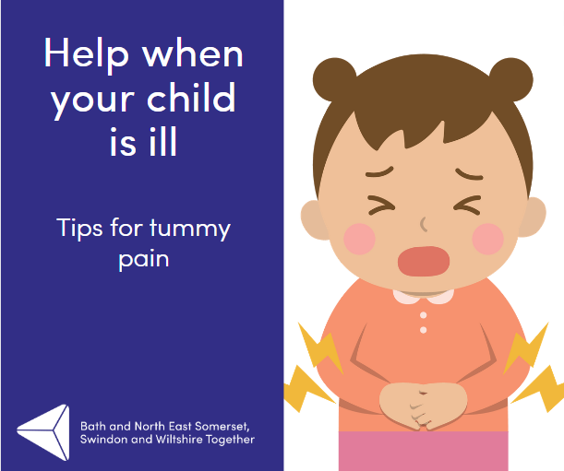 | Tummy pain is very common in children but can be worrying.  Most children will not need any specific treatment and the pain will get better by itself.  For more information on children’s illnesses, where to get help, and what you can do to help them at home visit the NHS website for more advice.  If you are worried that their symptoms are getting worse call 111 for advice. | Tummy pain in children can be common and concerning, but often, it resolves on its own without specific treatment.  For more guidance on caring for a sick child, visit the NHS website (link in bio). If you're concerned about worsening symptoms, call 111 for advice. 🩺💙 #ChildHealth #TummyTroubles #NHSAdvice | Child's tummy ache? Usually, it gets better on its own. Get more child health info on the NHS website.  . 🙌 #ChildHealth #NHSAdvice
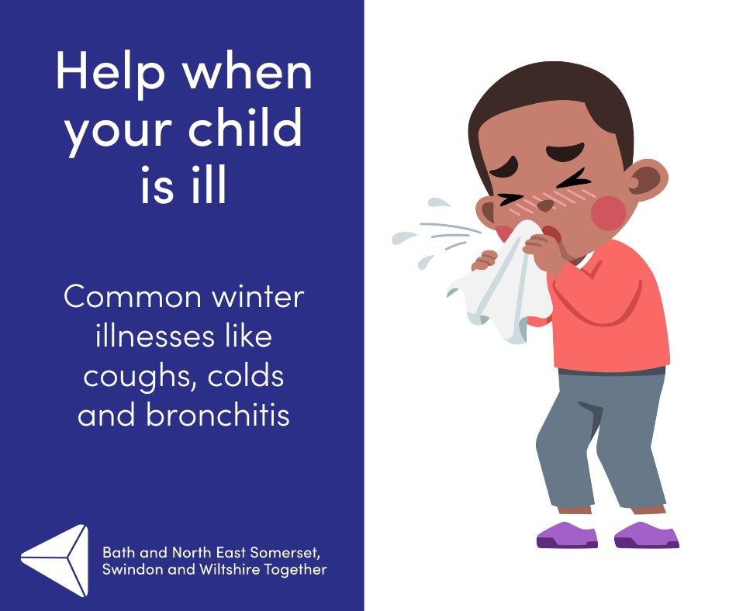 | Colds and most coughs are caused by a virus. Most colds last for 5-7 days, but the cough can hang around for longer.  Irritating coughs sometimes take several weeks to fully resolve, but if the child is otherwise well and isn’t having problems with their breathing, they are not normally something to worry about.  For more information on children’s illnesses, where to get help, and what you can do to help them at home visit the NHS website for more advice.  If you are worried that their symptoms are getting worse call 111 for advice. | Colds and coughs, often viral, can last 5-7 days. Coughs may linger but usually resolve. Don't fret if your child is well and breathing fine.  For more guidance on caring for a sick child, visit the NHS website (link in bio). If you're concerned about worsening symptoms, call 111 for advice. 🩺💙 #ChildHealth #ColdsAndCoughs #NHSAdvice | Most colds and coughs are viral and last around 5-7 days. Coughs might stick around longer, but if your child is well and breathing fine, no need to worry. Get more child health info on the NHS website.  . 🩺💙 #ChildHealth #ColdsAndCoughs #NHSAdvice
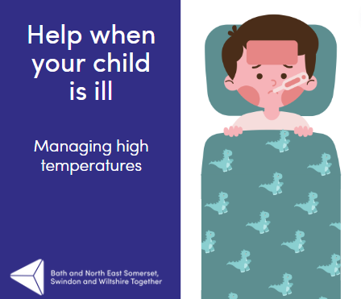 | When babies and children are unwell, they often have a high temperature (sometimes called a fever). This high temperature is the body’s way of helping to fight infection and is a very normal response.  It can be a worrying time for you but there is lots of help and advice on how to manage a high temperature at home on the NHS website.  (https://www.nhs.uk/conditions/baby/health/looking-after-a-sick-child/)  If you are worried that their symptoms are getting worse call 111 for advice. | High temperatures in sick babies and children are a natural response to fight infection. It can be concerning, but help and guidance for managing it at home can be found on the NHS website (link in bio). If you're concerned about worsening symptoms, call 111 for advice. 🩺💙 #ChildHealth #HighTemperature #NHSAdvice | 🌡️ High temps in kids fight infection. Get more child health info on the NHS website.  . If concerned, call 111. 🩺💙 #ChildHealth #NHSAdvice
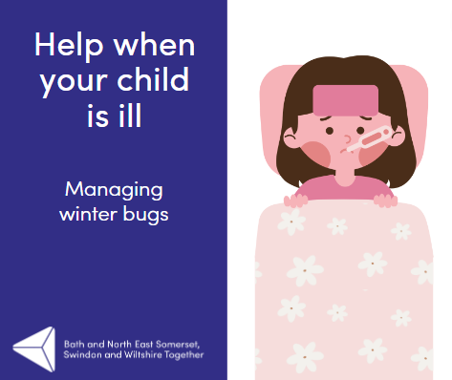 | ❄️Winter bugs and viruses are usually mild, but can sometimes become more serious, particularly in younger children or if an infection spreads to a vulnerable family member.  It can be hard to know what to do when your baby/child is ill and if you can manage this at home or need to see a doctor or nurse for more help.  For more information on children’s illnesses, where to get help, and what you can do to help them at home visit the NHS website for more advice.  If you are worried that their symptoms are getting worse call 111 for advice. | Winter bugs, often mild, can turn serious, especially in younger children or vulnerable family members. Knowing when to seek help can be tricky.  For guidance on caring for a sick child, visit the NHS website (link in bio). If symptoms worsen, call 111. 🩺💙 #ChildHealth #WinterIllness #NHSAdvice | Winter bugs can be mild but watch out. Unsure? Get more child health info on the NHS website.  If concerned, call 111. 🩺💙 #ChildHealth #NHSAdvice
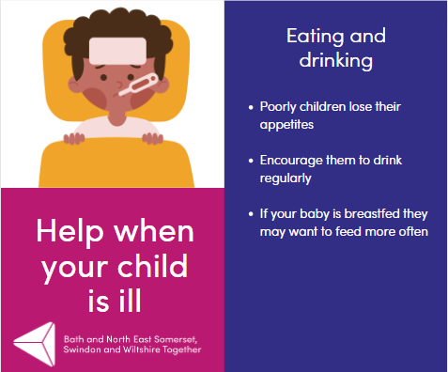 | Poorly children may not eat as much as normal, but encourage them to drink regularly💧  For more information on children’s illnesses, where to get help, and what you can do to help them at home visit the NHS website for more advice.  If you are worried that their symptoms are getting worse call 111 for advice. | When kids are under the weather, they might not eat much, but keep them hydrated! 💧  Find more child health info and home care tips on the NHS website (link in bio). If symptoms worsen, call 111. 🩺💙 #ChildHealth #HydrationMatters #NHSAdvice | Sick kids may eat less, but keep them hydrated! Get more child health info on the NHS website.  For concerns, call 111. 🩺💙 #ChildHealth #NHSAdvice
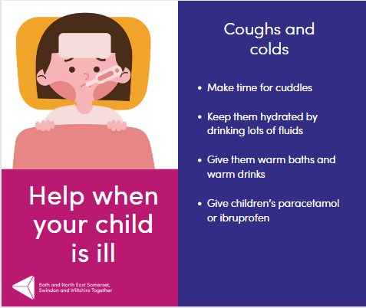 | Children often get a lot of coughs and colds and whilst it has to run its course, here are some things which you can do to make your child feel better 🤧🤒  For more information on children’s illnesses, where to get help, and what you can do to help them at home visit the NHS website for more advice.  If you are worried that their symptoms are getting worse call 111 for advice. | Children face many coughs and colds, but you can ease their discomfort. 💙  Find more child health tips on the NHS website (link in bio). If symptoms worsen, call 111. 🩺💙 #ChildHealth #NHSAdvice | Ease your child's coughs and colds. Get more child health info on the NHS website.  Concerned? Call 111. 🩺💙 #ChildHealth #NHSAdvice

