Easter prescriptions
Organic social media content

Copy | Asset | Alt text
Millions of people are using the NHS App to manage their health the easy way.  Find out how you can use the NHS App to order repeat prescriptions  ➡️ nhs.uk/nhs-services/online-services/how-to-order-a-repeat-prescription | 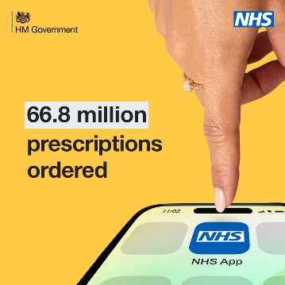 | A hand is pointing down towards a mobile phone screen that features the NHS App logo. Text reads; 66.8 million prescriptions ordered.
Check test results, order repeat prescriptions and much more. Manage your health the easy way with the NHS App.  Find out how you can use the NHS App to order repeat prescriptions  ➡️ nhs.uk/nhs-services/online-services/how-to-order-a-repeat-prescription | 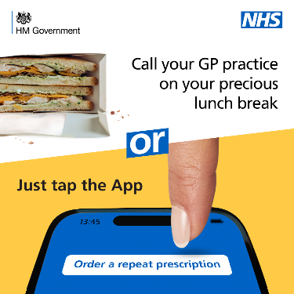 | A sandwich in the top left corner with a mobile phone in bottom of the image which says “order a repeat prescription” on screen. Text reads; call your GP practice on your precious lunch break or just tap the App.
Over the Easter break, your GP and local pharmacies will be closed.  Make sure you have plenty of essential medications to keep you going and order any repeat prescriptions now to give your practice plenty of time to process them. | 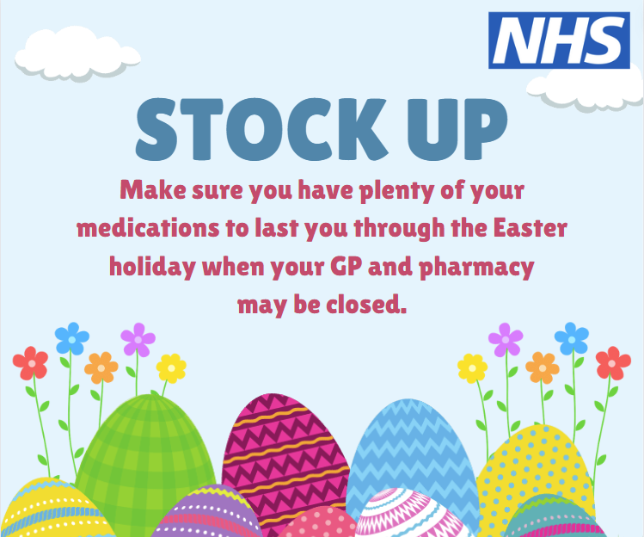 | A colourful selection of easter eggs and flowers with a sky background and NHS logo. Text reads; Stock Up - Make sure you have plenty of your medications to last you through the Easter holiday when your GP and pharmacy may be closed.
Over the Easter break, your GP and local pharmacies will be closed. Make sure you have plenty of essential medications to keep you going and order any repeat prescriptions as soon as possible to give your practice plenty of time to process them. | 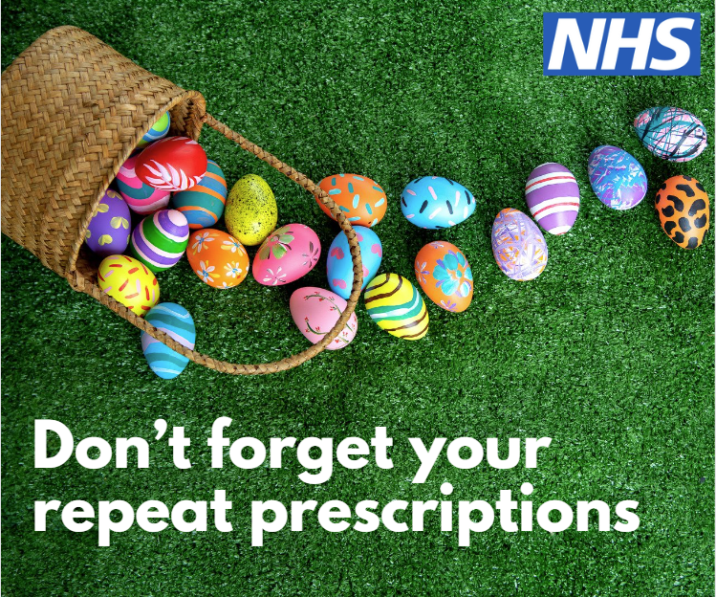 | A colourful selection of easter eggs and flowers with a sky background and NHS logo. Text reads; Don’t forget your repeat prescriptions

