Winter 22/23
Service Use

Communications Toolkit 25 November
This toolkit is designed to support BSW wide communications in the dissemination of consistent key messages and assets across all of our shared audiences to maximise our reach and engagement with our target audiences.

CONTENTS

- Campaign aims

- Campaign timings

- Social media assets

- Other assets

CAMPAIGN AIMS

- Drive awareness of the healthcare options available to parent with young children in their area (pharmacy, 111 online, 111 call, GP, MIU, A+E).
- Drive understanding of when it is appropriate to use these services.
- Build understanding about what can be expected from different services.
- Build understanding of the experience of different services.
- Build trust and credibility in each of these options individually.
- Educate on factors to consider when choosing a course of action.
- Cut-through with a fresh, innovative approach to our pressures messaging.

CAMPAIGN TIMINGS

There will be a focus on one service each week. The campaign will be topped and tailed with teaser content, behind the scenes videos and outtakes.

Service Use theme: Understand how to use services appropriately

From 24 Nov Teasers
w/c 28Dec MIU
w/c 5 Dec A+E
w/c 12 Dec 111
w/c 19 Dec GP and Walk-In Clinic
w/c 26 Dec Pharmacy
w/c 2 Jan Wrap-Up

SOCIAL MEDIA ASSETS - All Audiences

Assets and suggested copy available to download from the BSW Together Campaigns Page at www.bswtogether.org.uk/yourhealth/campaigns

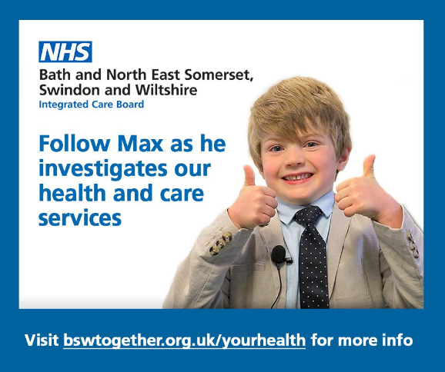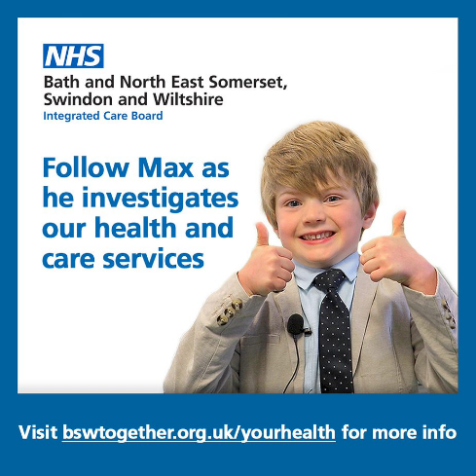

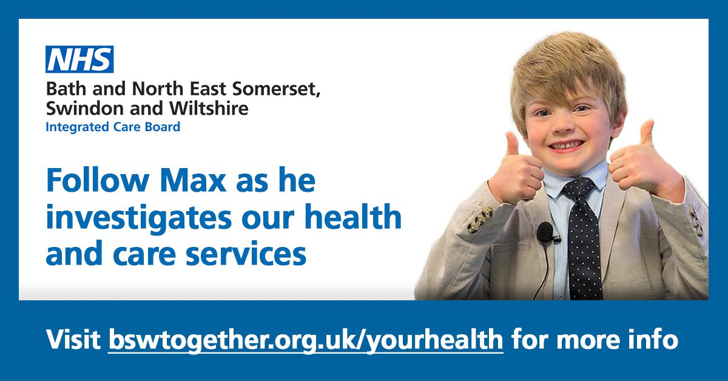

OTHER ASSETS

Website/E-Newsletter copy (generic)

Six-year-old Max helping to change health service behaviours this winter

Six-year-old Max Carter is helping to pass on important messages to members of the public this winter about how they can help support our health and care system by making the best use of services.

Max is taking part in a number of films which are looking to help change public behaviour when it comes to choosing health and care services for different situations.

The films feature interviews with clinicians and other healthcare professionals from different settings across BSW and explain who should use services and under what circumstances.

The series of Max Carter Investigates films feature interviews with health and care colleagues from Chippenham Minor Injuries Unit, a Lloyds pharmacy, a Radstock GP surgery and even 111.

The films explain in a clear and entertaining way who should be using each service, what they can provide, and how they can help. They are designed change public behaviour and pass on important messages in a simple way about how the public can help support health and care services through using the right setting for their needs.

The films will be available on our new Winter Portal at https://bswtogether.org.uk/yourhealth

Videos

https://www.youtube.com/playlist?list=PL9RTAicVhrksqmLRT2RMhgWAs6Cn7SlpN

The following edits are available on the resource centre:
- Full videos
- Intro and outtakes
- Reels
- Social media cut downs

The full videos available are as follows (length indicated in brackets)
Service | Video | Length
All | Max investigates introduction | 0.25
 | Max investigates outtakes | 0.30
Pharmacy | Pharmacy 1 – Max finds out all about pharmacies | 2.33
 | Pharmacy 2 – Max finds out about how to get help at a pharmacy | 2.11
 | Pharmacy 3 – What else Max found out about at the pharmacy | 2.06
 | Pharmacy 4 – What the biggest secret you wish everyone knew about the Pharmacy | 1.07
 | Pharmacy 5 teaser - What’s the biggest secret you wish everyone knew about Pharmacy | 0.29
MIU | MIU – Who can come to MIU | 2.01
 | MIU 1 – Max finds out all about MIU | 2.13
 | MIU 2 - Max finds out about how to get help at a MIU | 1.10
 | MIU 3 – Who can come to MIU | 0.20
 | MIU 4 teaser – Who can come to MIU
 | MIU – Mummy thinks I need help - How to use 111 | 1.15
 | GP1 – Max finds out all about GP surgeries | 2.18
 | GP2 - Max finds out about how to get help a at GP surgery | 2.24
 | GP3 teaser – What’s the one thing you wish everyone knew about contacting a GP surgery | 0.23
A&E | A&E explainer part | 2.00
 | A&E – main explainer part | 1.58
 | A&E the biggest secret | 0.26
111 | 111 – main explainer part 1 | 2.03
 | 111 – main explainer part 2 | 1.56

Screen Savers

All assets

All assets are available to download from the BSW Together Campaigns Page at www.bswtogether.org.uk/yourhealth/campaigns

