Date | Copy | Asset
13 Nov | National Self Care Week 2022 starts tomorrow!  Self care looks different for everyone, but it's more important than ever that we look after ourselves and those around us.  Look out for our self care tips throughout the week.  #SelfCareForLife @SelfCareForum | 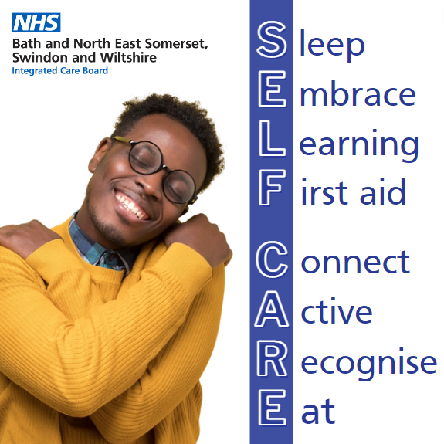
14 Nov | Getting enough good quality sleep is vital to maintaining mental and physical wellbeing.  Not getting enough “good quality sleep” can sap your energy levels, lower your mood and reduce your concentration.  For more information about sleep and other self care tips visit https://bit.ly/BSWselfcare22  #SelfCareForLife @SelfCareForum | 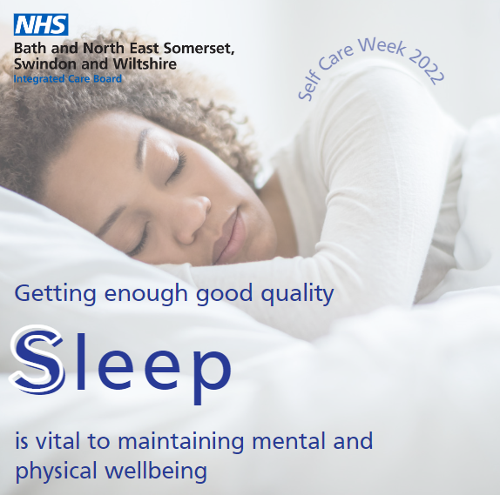
 | Embrace who you are and remember your mental health does not define you - it’s just a part of what makes you, you!  For more information about mental health and other self care tips visit https://bit.ly/BSWselfcare22  #SelfCareForLife @SelfCareForum | 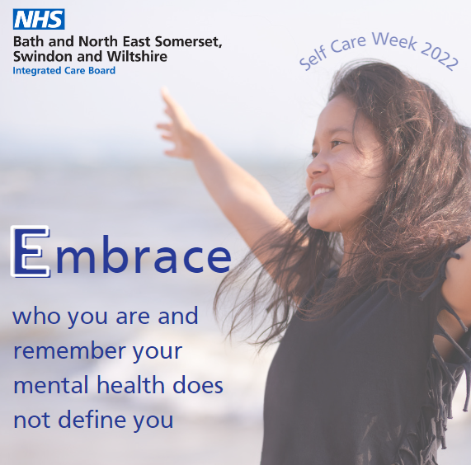
15 Nov | Continued learning through life enhances self-esteem and encourages social interaction and a more active life.  Why not learn something new today?  For ideas and other self care tips visit https://bit.ly/BSWselfcare22  #SelfCareForLife @SelfCareForum | 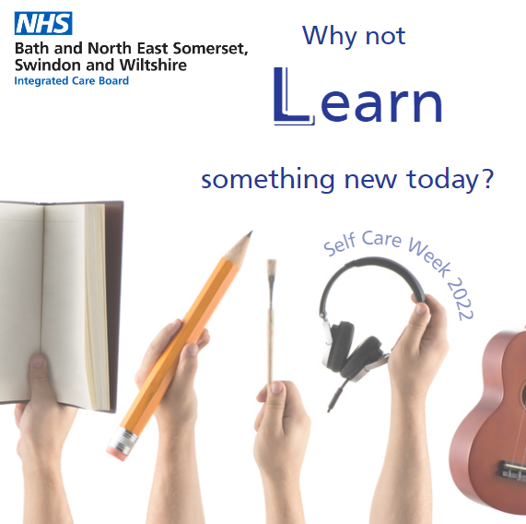
 | Is your medicine cabinet stocked up?  Help your family stay well at home with these essentials which you can pick up from your local pharmacy.  #SelfCareForLife @SelfCareForum | 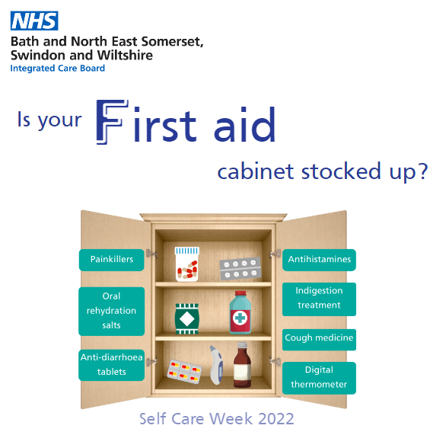
16 Nov | Feeling close to, and valued by, other people is a fundamental human need and one that contributes to functioning well in the world.  Our relationships are critical for maintaining our wellbeing.  For more information about this and other self care tips visit https://bit.ly/BSWselfcare22  #SelfCareForLife @SelfCareForum | 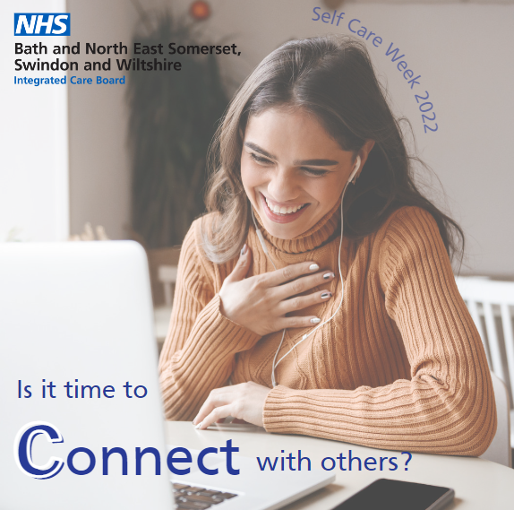
 | Regular physical activity is associated with lower rates of depression and anxiety across all age groups.  Simple activities such as walking ticks the box and also has the benefit of encouraging social interactions.  For more information about staying active and other self care tips, visit https://bit.ly/BSWselfcare22  #SelfCareForLife @SelfCareForum | 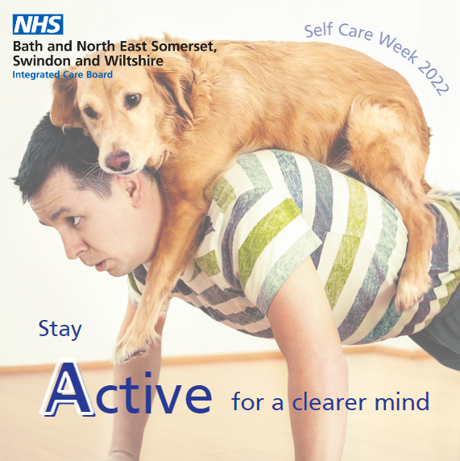
17 Nov | Reminding yourself to ‘take notice’ can strengthen and broaden awareness.  Take some time to enjoy the moment and the environment around you.  For more information about maintaining your mental health and other self care tips, visit https://bit.ly/BSWselfcare22  #SelfCareForLife @SelfCareForum | 
 | Evidence suggests that as well as affecting our physical health, what we eat may also affect the way we feel.  Improving your diet may help to improve your mood, give you more energy and help you think more clearly.  For more information about maintaining a healthy diet and other self care tips, visit https://bit.ly/BSWselfcare22  #SelfCareForLife @SelfCareForum | 