Notes:
- When tagging, please note that the ICB account on Instagram is @NHSBSWCCG. On other channels, it’s @NHSBSWICB
- For reels and cut-down videos, please email bswicb.digitalcommunications@nhs.net

Channel | Short copy | Long copy | Asset
Facebook  Twitter | Reporter Max is on a mission to find out more about your local health services!  Find out what Max learnt from the dedicated teams behind the scenes in @NHSBSWICB new YouTube series ➡️ bit.ly/MaxInvestigates | Reporter Max is on a mission to find out more about your local health services!  He visited a local minor injury unit, walk-in centre, pharmacy, GP surgery and A+E department, and had a conversation with a 111 call handler.  Asking the difficult questions, so you don't have to.  Find out what Max learnt from the dedicated teams behind the scenes in @NHSBSWICB new YouTube series ➡️ bit.ly/MaxInvestigatesBSW  #MaxInvestigates | [use link preview]
Instagram |  | Reporter Max is on a mission to find out more about your local health services!  He visited a local minor injury unit, walk-in centre, pharmacy, GP surgery and A+E department, and had a conversation with a 111 call handler.  Asking the difficult questions, so you don't have to.  Find out what Max learnt from the dedicated teams behind the scenes in @NHSBSWCCG new YouTube series, link in their bio.  #MaxInvestigates
LinkedIn |  | Our new campaign follows Max on his mission to find out more about healthcare services in our area!  He visited a local minor injury unit, walk-in centre, pharmacy, GP surgery and A+E department, and had a conversation with a 111 call handler.  Asking the difficult questions, so you don't have to.  Find out what Max learnt from the dedicated teams behind the scenes in @NHSBSWICB new YouTube series ➡️ bit.ly/MaxInvestigatesBSW  #MaxInvestigates | [intro/intro reel]
Facebook  Twitter |  | @NHSBSWICB have launched a new video series on their YouTube channel called Max Investigates.  Find out what Max learnt from the dedicated teams behind the scenes in your local health settings!  Asking the difficult questions, so you don’t have to.  ➡️ bit.ly/MaxInvestigatesBSW  #MaxInvestigates
Instagram |  | @NHSBSWCCG have launched a new video series on their YouTube channel called Max Investigates.  Find out what Max learnt from the dedicated teams behind the scenes in your local health settings!  Asking the difficult questions, so you don’t have to.  Click the link in their bio to watch.  #MaxInvestigates | [intro reel]
Facebook  Twitter  Instagram |  | The Max Investigates series on @NHSBSWICB / @NHSBSWCCG YouTube channel helps you make the right decisions when it comes to your health.  Max asks the difficult questions, so you don’t have to.  Check it out at bit.ly/MaxInvestigatesBSW | [intro/intro reel]
Facebook  Twitter  Instagram |  | Max Investigates is @NHSBSWICB / @NHSBSWCCG new video series about local health services.  All episodes now available on YouTube at bit.ly/MaxInvestigatesBSW  Learn more about local health services, get answers to your questions and help others by sharing far and wide!  #MaxInvestigates | [Alex graphic]
Facebook  Twitter  Instagram |  | Undercover reporter Max takes a closer look at local health services and finds out what they have to offer.  Watch on YouTube: bit.ly/MaxInvestigatesBSW  #MaxInvestigates | [intro/intro reel]
Facebook  Twitter  Instagram |  | Max has been on a mission to find out more about the health services in your area.  Get answers to your question at bit.ly/MaxInvestigatesBSW  #MaxInvestigates | [Alex graphic]

MIU
Channel | Short copy | Long copy | Asset
Facebook  Twitter | Max asks the difficult questions, so you don’t have to.  Find out what he learned from Barry about your local minor injury unit in our new video series, now live on YouTube!  👉 bit.ly/MaxInvestigatesBSW  #MaxInvestigates |  | 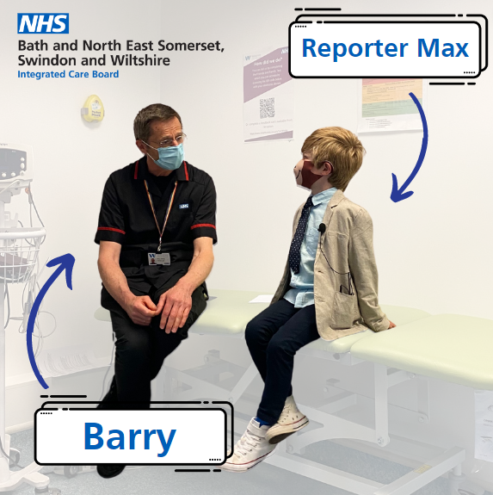
Instagram | Max asks the difficult questions, so you don’t have to.  Find out what he learned from Barry about your local minor injury unit in our new video series, now live on YouTube!  Click the link in @NHSBSWCCG bio.  #MaxInvestigates
Facebook  Twitter | Max Investigates: Who can come to an MIU?  Get answers from the healthcare teams behind the scenes in @NHSBSWICB new video series.  Watch the full series on YouTube now 👉 bit.ly/MaxInvestigatesBSW  #MaxInvestigates |  | [cut-down video]
Facebook  Twitter | Max isn’t afraid to ask the tough questions.  Today he asks: what should mummy do if she thinks I need help?  Find out what he discovered in his new video series, live now on YouTube 👉 bit.ly/MaxInvestigatesBSW  #MaxInvestigates |  | [cut-down video]

Pharmacy
Channel | Short copy | Long copy | Asset
Facebook  Twitter | Max is curious about what goes on behind the scenes in your local pharmacy.  Find out what he discovers from Kalpesh in @NHSBSWICB new YouTube series 👉 bit.ly/MaxInvestigatesBSW |  | 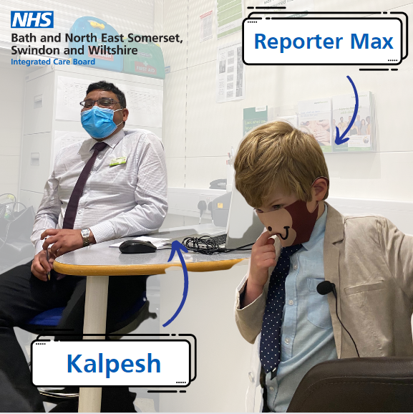
Instagram | Max is curious about what goes on behind the scenes in your local pharmacy.  Find out what he discovers from Kalpesh in @NHSBSWCCG new YouTube series. Simply click the link in their bio.  #MaxInvestigates
Facebook  Twitter | Max Investigates: What’s the biggest secret you wish everyone knew about the pharmacy?  Max uncovers the facts on local health services, so you can make the best choice for your family.  Watch on YouTube 👉 bit.ly/MaxInvestigatesBSW |  | [cut-down video]

111
Channel | Short copy | Long copy | Asset
Facebook  Twitter | How can NHS 111 help me?  Who can use 111?  Find out what reporter Max discovered in @NHSBSWICB new YouTube series 👉 bit.ly/MaxInvestigatesBSW |  | 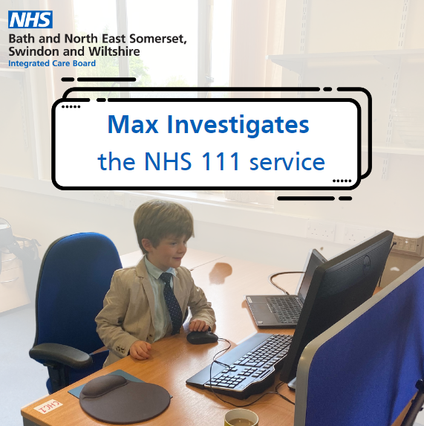
Instagram | How can NHS 111 help me?  Who can use 111?  Find out what reporter Max discovered in @NHSBSWCCG new YouTube series. Visit their profile and click the link in their bio.
Facebook  Twitter | When should my mummy call 111 and when should she go online?  Get answers from the healthcare teams behind the scenes in @NHSBSWICB new video series.  Watch the full series on YouTube now 👉 https://www.youtube.com/watch?v=uNqeQxFLaTE&list=PL9RTAicVhrksqmLRT2RMhgWAs6Cn7SlpN&index=7 |  | [use link preview]

GP / walk-in
Channel | Short copy | Long copy | Asset
Facebook  Twitter | What happens if my mummy thinks I need a GP?  What kind of conditions can you help with?  Find out what reporter Max discovered in @NHSBSWICB new YouTube series 👉 bit.ly/MaxInvestigatesBSW |  | 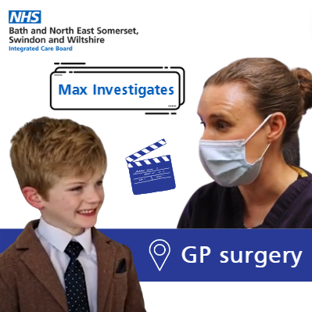
Instagram | What happens if my mummy thinks I need a GP?  What kind of conditions can you help with?  Find out what reporter Max discovered in @NHSBSWCCG new YouTube series. Simply click the link in their bio.
Facebook  Twitter | Max Investigates: What’s the one thing you wish everybody knew about contacting a GP?  Find out what Max learnt from the dedicated teams behind the scenes!  Watch the series on @NHSBSWICB YouTube channel 👉 bit.ly/MaxInvestigatesBSW |  | [GP cut-down video]
Facebook  Twitter | Max Investigates: What kind of people can you help at a walk-in centre?  Find out what reporter Max discovered!  Watch the series on @NHSBSWICB YouTube channel 👉 bit.ly/MaxInvestigatesBSW |  | [WIC cut-down video]

A+E
Channel | Short copy | Long copy | Asset
Facebook  Twitter | Reporter Max asks the difficult questions, so you don’t have to.  Find out what Sarah revealed about A+E in @NHSBSWICB new video series, live on YouTube 👉 bit.ly/MaxInvestigatesBSW |  | 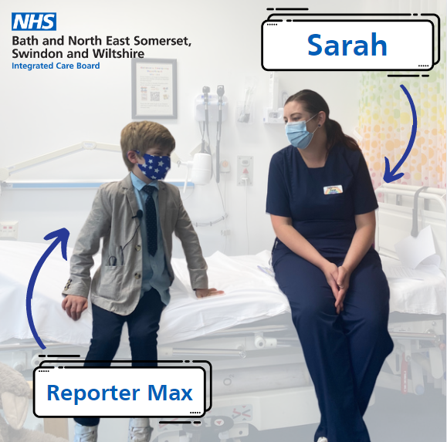
Instagram | Reporter Max asks the difficult questions, so you don’t have to.  Find out what Sarah revealed about A+E in @NHSBSWCCG new video series, live on YouTube. Simply click the link in their bio.
Facebook  Twitter | Max Investigates: What’s the biggest secret you wish everybody knew about A+E?  Max uncovers the facts on local health services, so you can make the best choice for your family.  Watch on YouTube 👉 bit.ly/MaxInvestigatesBSW  @NHSBSWICB |  | [cut-down video]

