Topic | Copy | Asset
Pharmacy (prescriptions) | Prescription medicine for a range of common health conditions is now available from a growing number of local pharmacies!  More than 80 pharmacies across BSW are now able to give out medicine for 5 common health conditions that would have previously needed a prescription from a GP.  Find a list of participating pharmacies at bswtogether.org.uk/yourhealth/ | 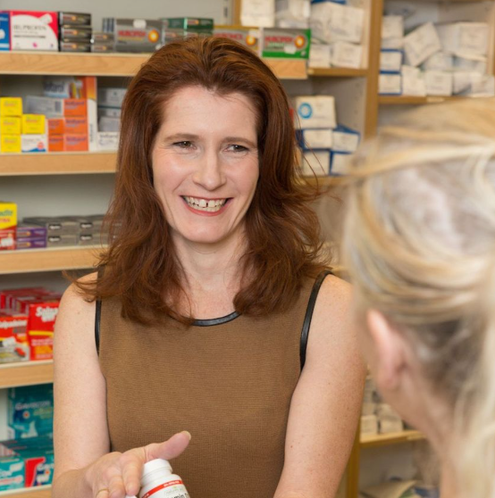
Pharmacy (opening times) | Christmas and New Year opening hours for local pharmacies are now available online ➡️ bswtogether.org.uk/yourhealth/pharmacies/  A number of pharmacies will stay open on the bank holidays, for help with a minor condition or general healthcare advice. | 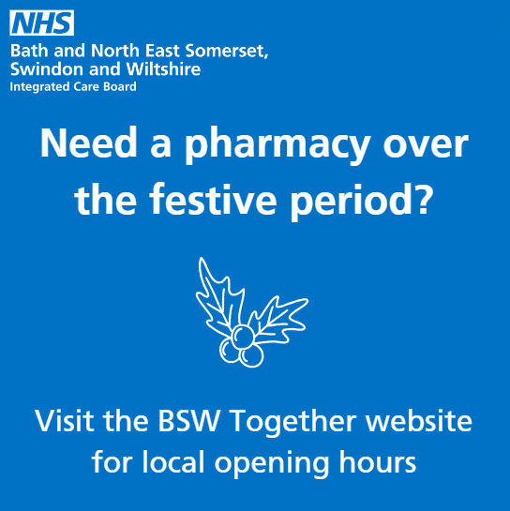
Pharmacy (opening times) | If you unexpectedly need urgent medication over the next few weeks, rest assured many local pharmacies will still be open for limited hours.  Check the opening times for the festive period on our website ➡️ bswtogether.org.uk/yourhealth/pharmacies/
Service use  Self-care | Many minor illnesses and injuries can be cared for at home, with no need to visit your GP.  Visit nhs.uk clinical advice on the symptoms and treatment for hundreds of common illnesses. | 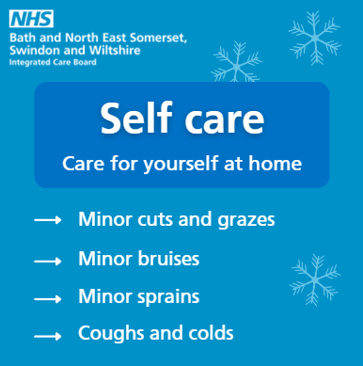
Service options  MIU | What’s a Minor Injury Unit? 🤔  MIUs are run by experienced clinicians and are available to treat non-life-threatening injuries, such as:  ✔️ sprains and strains  ✔️ broken bones  ✔️ minor burns and scalds  MIUs cannot treat any minor illnesses, such as stomach pains, mild allergic reactions or pregnancy problems.  If you have a non-life-threatening injury, go to www.111.nhs.uk. Our trained clinicians will help you to get the right treatment, such as making a trip to your local MIU if necessary. | 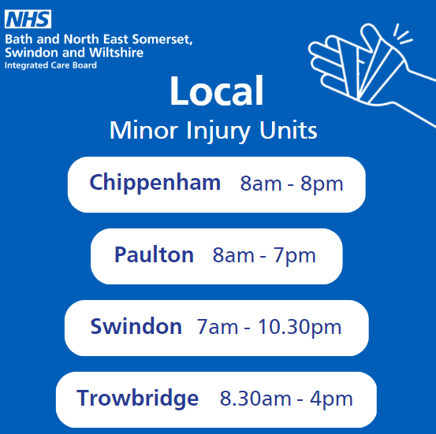
Service options  Pharmacy | If you or your child have a minor illness such as a cough or cold, your local pharmacist could help.  Simply visit your local pharmacy for confidential medical advice. | 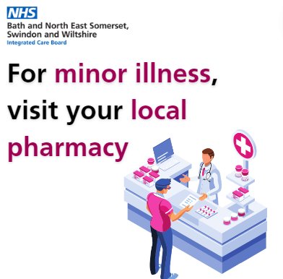
Service options  Pharmacy | Did you know your local pharmacist can help with free, confidential advice? 💊  So don't wait for a minor illness to get worse, ask your pharmacy team first.
Service options  Mental health | Did you know, there is a local dedicated telephone line offering support for adults and children in a mental health crisis?  Avon and Wiltshire Mental Health Partnership NHS Trust (AWP) offer the service for anyone who may be worried about their own or someone else's mental health.  If you or your loved one feels unsafe, at risk, or unable to cope without professional advice, their dedicated staff will ensure that you are directed to the team best able to meet your needs.  The number to call is 0800 953 1919 📞  In a life-threatening emergency, always dial 999.  Find more mental health support at bit.ly/BSWmentalhealthsupport | 
Service options  Mental health | Kids home for Christmas?  We have produced a great, free resource to help families communicate about mental health.  Our series of films help children, young people, and their families to talk about feelings and thoughts.  Find the full series on our YouTube channel ➡️ https://www.youtube.com/channel/UCl_TDbv_ZHo6AeQaPokmhYg  Find local mental health support at bit.ly/BSWmentalhealthsupport | [Create Studios cut-down video]
Service options  Mental health | This Christmas, are you feeling a little less festive and a little more… meh? 😕  You’re not alone.  Find local mental health support at bit.ly/BSWmentalhealthsupport | 
Service options  General | If you feel unwell, please consider all your healthcare options.  ➡️ Pharmacists can offer clinical advice on minor illnesses.  ➡️ Contact 111.nhs.uk for urgent care, or 999 in an emergency only  ➡️ MIUs are available to treat non-life-threatening injuries  ➡️ nhs.uk gives clinical advice on a range of conditions  ➡️ Your GP is there for long-term conditions or symptoms that don't go away | 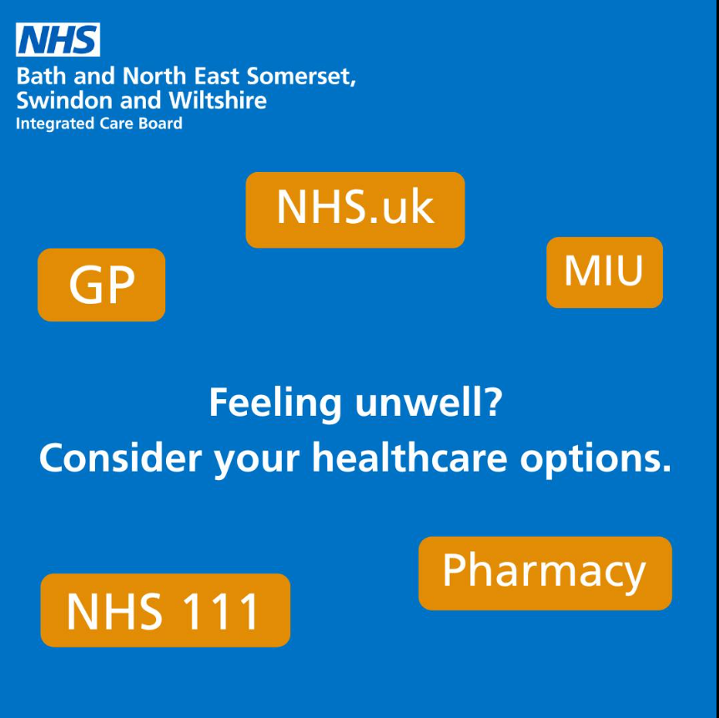
Service options  111 | If you have an urgent but not life-threatening medical need, make sure you visit NHS 111 online first.  NHS 111 online will help you right away and, if needed, a healthcare professional will call you.  NHS 111 online can direct you to an urgent treatment centre/walk in centre, emergency dental services, GP, pharmacy, or another more appropriate local service.  👉 www.111.nhs.uk  If you or your loved one have a life-threatening illness or injury then you should always dial 999. | 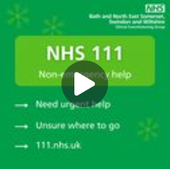
Specific ailments  Sore throat | Did you know you can get help for a sore throat at your local pharmacy?  Some can even prescribe medication, to help you feel better.  Next time you have a minor illness, ask your pharmacy team first. | 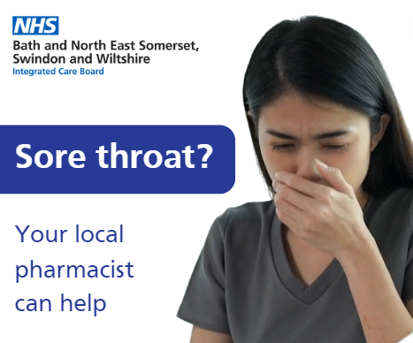
Norovirus | 🤢 Norovirus is circulating at the moment so protect yourself this Christmas by regularly washing your hands with soap and warm water.  Remember that alcohol hand gels DON'T kill norovirus! | 