Antibiotic awareness toolkit
The toolkit aims to provide content to inform people about the correct use of antibiotics and the risks associated with poor use. Graphics can be accessed by right clicking on them and saving as images.
Channel | Short copy | Long copy | Asset
Facebook  Twitter | Find out how you can help prevent antimicrobial resistance in this short video.  #AntibioticGuardian  #KeepAntibioticsWorking  #WAAW2022 | What is antimicrobial resistance?  When bacteria, viruses, fungi and parasites change over time and no longer respond to medicines, making infections harder to treat and increasing the risk of disease spread, severe illness and death.  Find out how you can help prevent antimicrobial resistance in this short video. | [video]  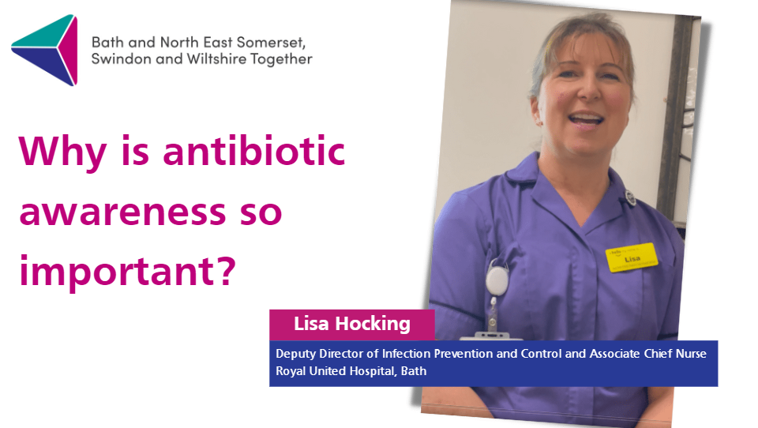  https://www.youtube.com/watch?v=Qqg0HNm4CKg:
Facebook  Twitter | Prevention is better than cure.  By washing our hands we prevent the spread of infection. It also means we reduce our antibiotic use, which is all part of the effort to reduce the spread of antibiotic resistance.  # | Prevention is better than cure.  By washing our hands we prevent the spread of infection, protecting ourselves and others. It also means we reduce our antibiotic use, which is all part of the effort to reduce the spread of antibiotic resistance.  Become an antibiotic guardian at https://antibioticguardian.com/ | 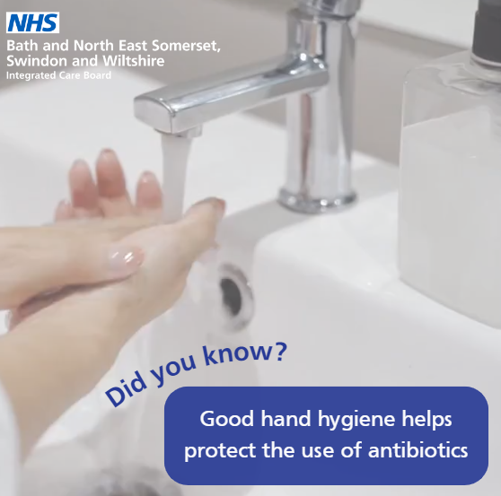
Instagram |  | Prevention is better than cure.  By washing our hands we prevent the spread of infection, protecting ourselves and others. It also means we reduce our antibiotic use, which is all part of the effort to reduce the spread of antibiotic resistance.
Facebook  Twitter | Antibiotics don’t work for viruses like flu.  Instead...  ✅Use over-the-counter or home treatments that will help with symptoms whilst the immune system fights off the infection  ✅Get your flu vaccine | Antibiotics are fantastic, but they don’t work for viruses like flu.  Instead...  ✅Use over-the-counter or home treatments that will help with symptoms whilst the immune system fights off the infection  ✅ Find out how to get your flu vaccine at bit.ly/BSWfluvax | https://www.youtube.com/watch?v=zTbLai2GaQM
Facebook  Twitter | If you’re prescribed antibiotics, it’s important to complete the full course.  Finishing early can make it easier for bacteria to develop resistance to antibiotics. | If you’re prescribed antibiotics, it’s important to complete the full course to make sure the infection is properly treated, even if you start to feel better.  Finishing treatment courses early can make it easier for bacteria to develop resistance to antibiotics. We all need to keep antibiotics working. | https://www.youtube.com/watch?v=zTbLai2GaQM
Facebook  Twitter  Instagram | Antibiotics should never be shared with others because:  ➡️ It’s not safe  ➡️ If people take antibiotics they don’t need or take partial courses, it means bacteria have more chance of becoming resistant | Antibiotics should never be shared with others because:  ➡️ It’s not safe - prescribers need to know someone’s medical history, what they’re treating, any allergies and reasons for changes in dosage  ➡️ If people take antibiotics they don’t need or take partial courses, it means bacteria have more chance of becoming resistant  Antibiotics are a precious resource, and we need to look after them to keep routine treatments like simple operations safe. | 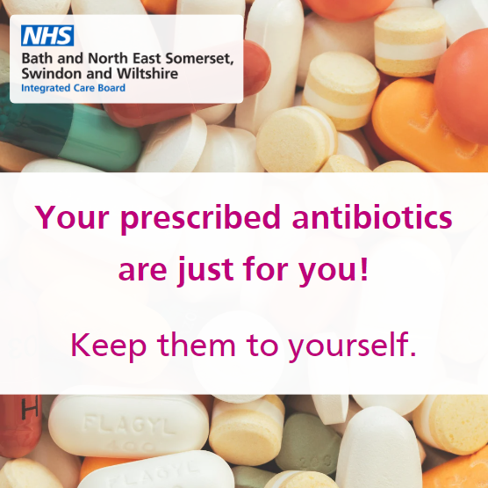
Facebook  Twitter | Antibiotics can affect our environment and our wildlife.  Don’t flush unwanted or expired medication!  You can return it to your local pharmacy ➡️ nhs.uk/service-search/pharmacy/find-a-pharmacy |  | 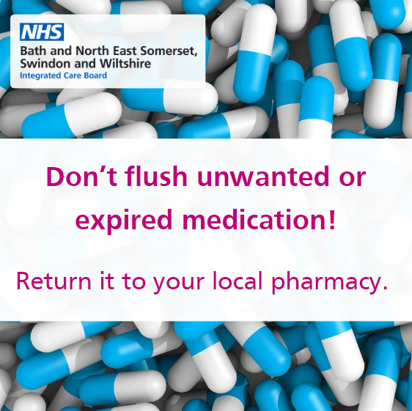
Instagram |  | Antibiotics can affect our environment and our wildlife.  Don’t flush unwanted or expired medication!  You can return it to your local pharmacy.

