FALLS PREVENTION ASSETS

 | Facebook | Instagram  Add this link to your bios: https://bswtogether.org.uk/yourhealth/self-care/ | Twitter
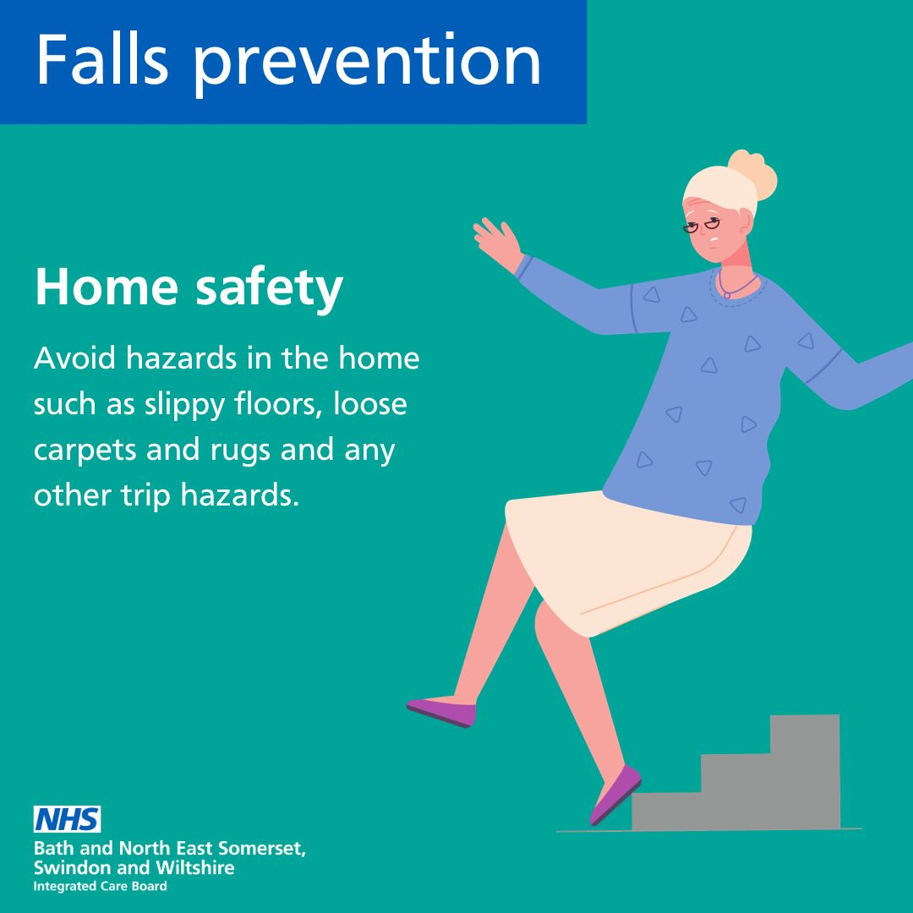 | Many older adults fall at home each year due to common household hazards.  You can make your home safe by removing trip hazards, and ensuring that flooring is well secured. https://bit.ly/44VPoa3 | Ensure a safe haven! Many older adults experience falls at home due to common hazards. Make your space secure by removing trip risks and securing your flooring.  For more tips visit the link in the bio. | Make your home a safe haven! Common household hazards lead to falls among older adults. Remove trip risks and secure your flooring.  More tips: https://bswtogether.org.uk/yourhealth/self-care/
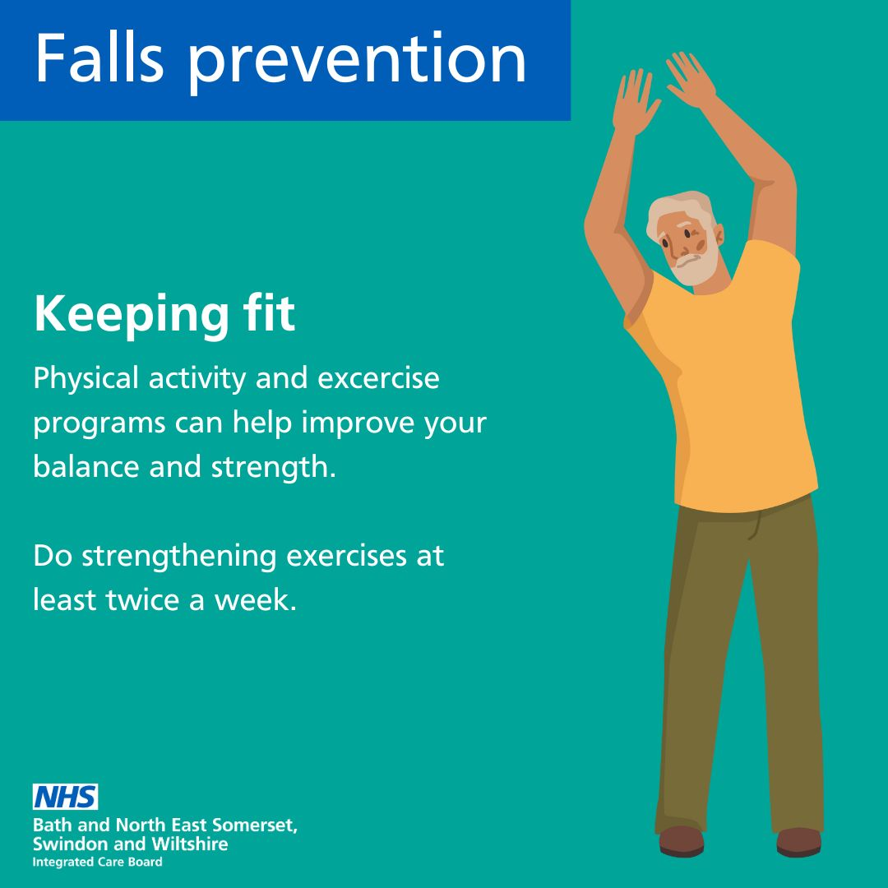 | Exercise plays a crucial role in preventing falls particularly among older adults. Strength and balance exercises as little as twice weekly can help you stay steady, enhance strength and reduce joint pain.  You might find yourself feeling unsteady or maybe starting to fear falling as you age. There are exercise programs that can help improve balance, strength and flexibility. https://bit.ly/44VPoa3 | Stay steady and strong! Exercise is key in preventing falls, especially for older adults. Incorporate strength and balance workouts twice a week to enhance stability and reduce joint pain.  For more tips visit the link in the bio. | Stay strong, stay steady! For older adults, regular strength and balance exercises twice a week can enhance stability and reduce joint pain.  More tips: https://bswtogether.org.uk/yourhealth/self-care/
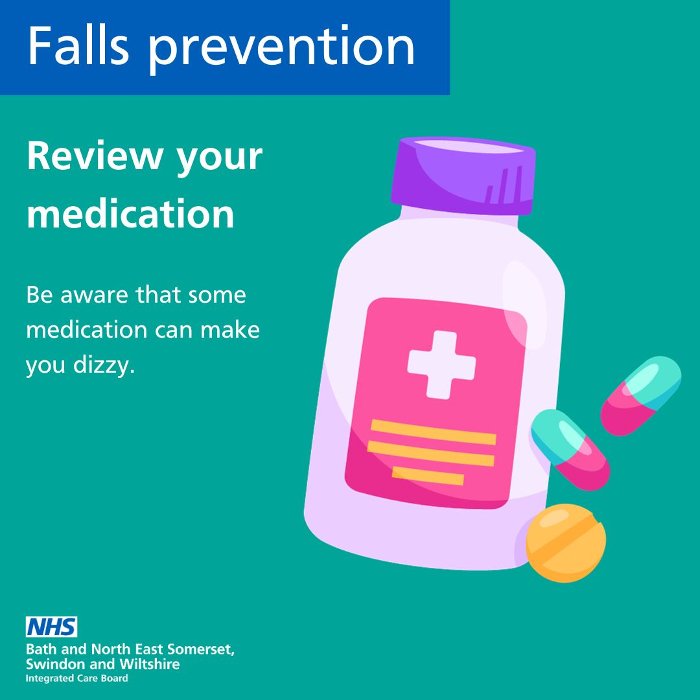 | Taking more than one medication increases the chances of side effects and the risk of falling. Check with your pharmacist that your medications are not increasing your risk of falling. https://bswtogether.org.uk/yourhealth/self-care/ | Medication check! Taking multiple medications increases fall risks. Consult your pharmacist to ensure your prescriptions aren't putting you at risk.  For more tips visit the link in the bio. | Medication check! Multiple medications increase fall risks. Consult your pharmacist to ensure your prescriptions are not putting you at risk.  More tips: https://bswtogether.org.uk/yourhealth/self-care/
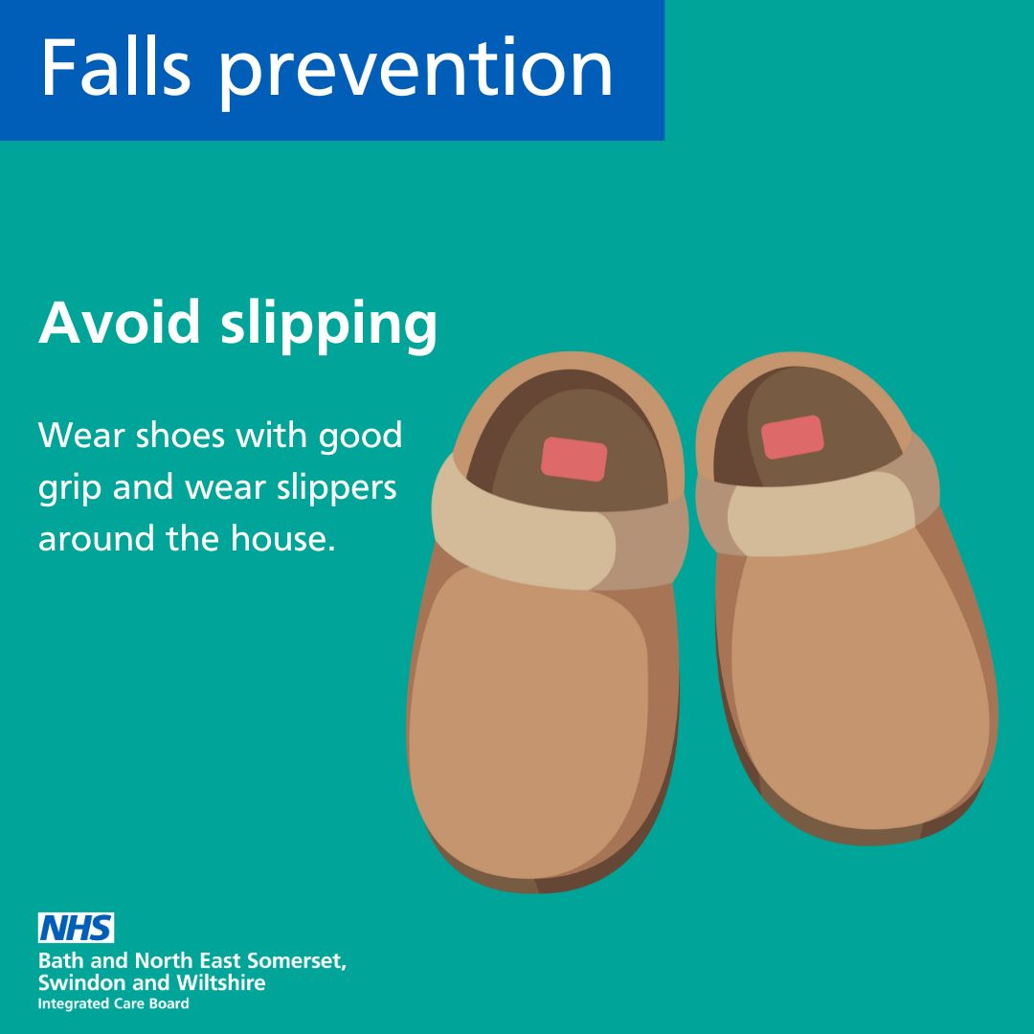 | You can help prevent slipping by wearing shoes with good grip outside and using slippers when you are in your home. https://bit.ly/44VPoa3 | Wear shoes with good grip outdoors and comfy slippers at home to prevent slipping. Safety first!  For more tips visit the link in the bio. | Slip-proof your steps! Wear shoes with good grip outdoors and comfy slippers at home to prevent slipping. Safety first!  More tips: https://bswtogether.org.uk/yourhealth/self-care/
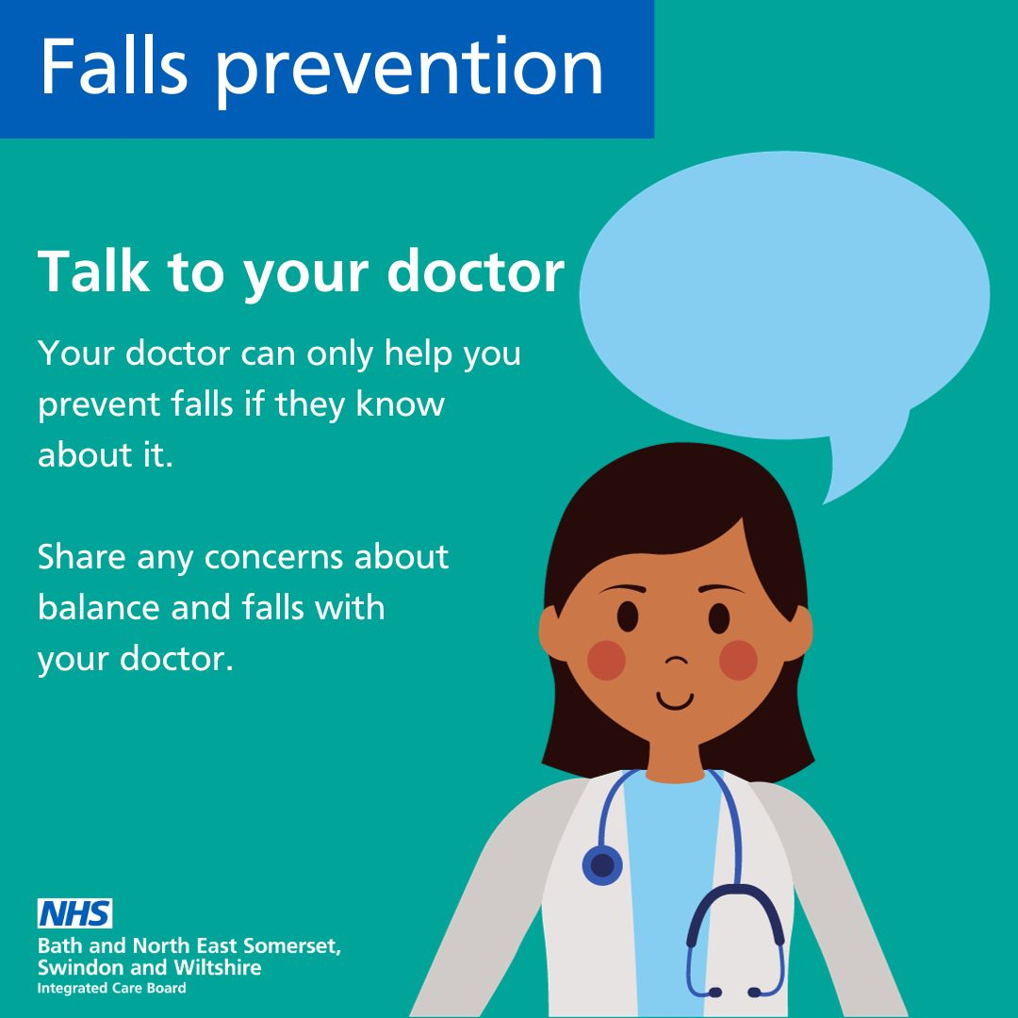 | One in four older adults falls each year, but only half tell their doctor. They can only help with your falls if they know about them. https://bit.ly/44VPoa3 | Don't keep falls a secret! 1 in 4 older adults fall each year, but only half tell their doctors. Share your experiences to receive the help you need.  For more tips visit the link in the bio. | Don't keep falls a secret! 1 in 4 older adults fall each year, but only half tell their doctors. Share your experiences to receive the help you need.  More tips: https://bswtogether.org.uk/yourhealth/self-care/
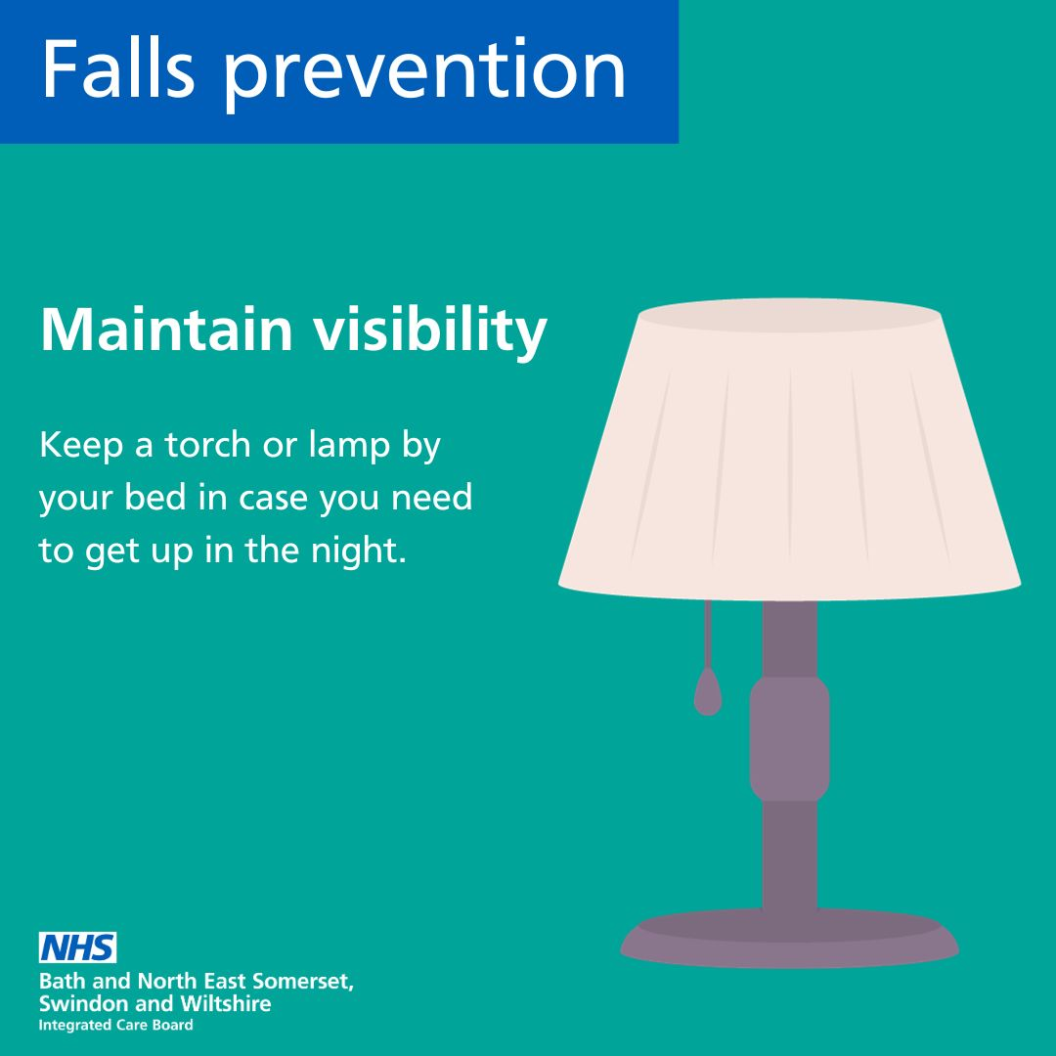 | Make sure you have good accessible lighting throughout your home so you do not need to move around in the dark when you may not be able to see where you are going. https://bit.ly/44VPoa3 | Illuminate your life! Good lighting is crucial to navigate your home safely. Avoid wandering in the dark with accessible lighting throughout.  For more tips visit the link in the bio. | Illuminate your life! Good lighting is crucial to navigate your home safely. Avoid wandering in the dark with accessible lighting throughout.  More tips: https://bswtogether.org.uk/yourhealth/self-care/
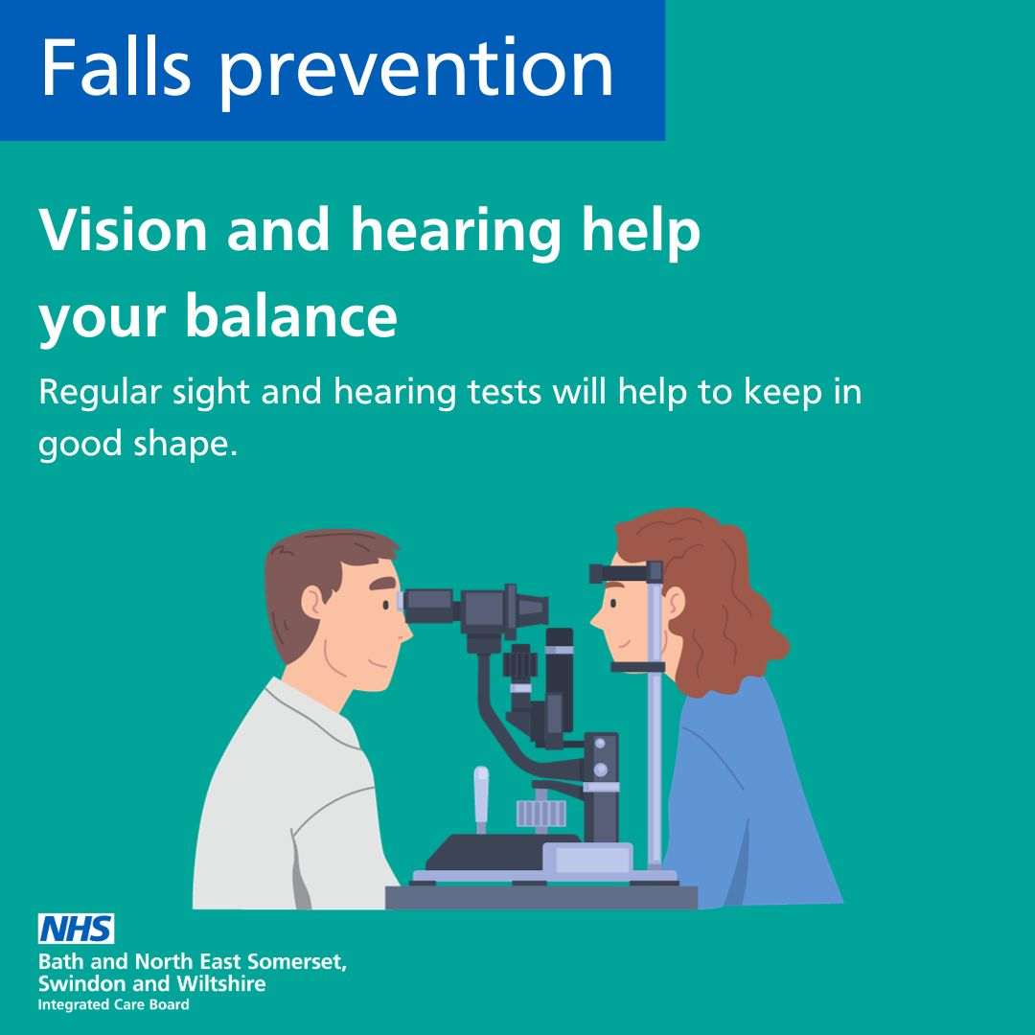 | Your vision and hearing play an important role in maintaining good balance, which is needed for everyday activities to prevent falls. Regular heating and eye tests can help to ensure you stay in good health. https://bswtogether.org.uk/yourhealth/self-care/ | Preserve your balance! Regular vision and hearing tests contribute to maintaining good balance for everyday activities.  For more tips visit the link in the bio. | Preserve your balance! Regular vision and hearing tests contribute to maintaining good balance for everyday activities.  More tips: https://bswtogether.org.uk/yourhealth/self-care/

