Strep A

Communications Toolkit
This toolkit is designed to support BSW wide communications in the dissemination of consistent key messages and assets across all of our shared audiences to maximise our reach and engagement with our target audiences.

CONTENTS

- Campaign aims

- Campaign timings

- Social media assets

- Other assets

CAMPAIGN AIMS

- Drive awareness and understanding of the Group A streptococcus (GAS) bacteria in terms of:
  - What it is
  - How to identify it
  - How to manage it
- Manage public concern about the impact of the bacteria in light of ongoing national press about more serious cases.
- Educate around more general childhood winter illnesses – what they are, how to identify them and what to do.
- Educate around steps the public can take to keep the under 5 population well this Winter.

SOCIAL MEDIA ASSETS - All Audiences

Assets and suggested copy available to download from the BSW Together Campaigns Page at www.bswtogether.org.uk/yourhealth/campaigns

Strep A
Currently re-sharing UKHSA content (available on Campaign Resource Centre)

RSV
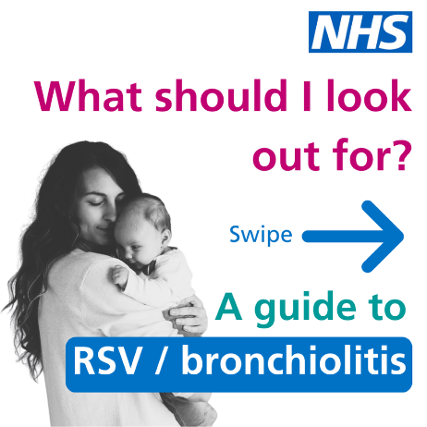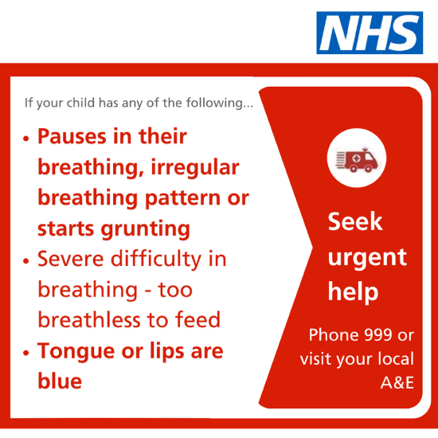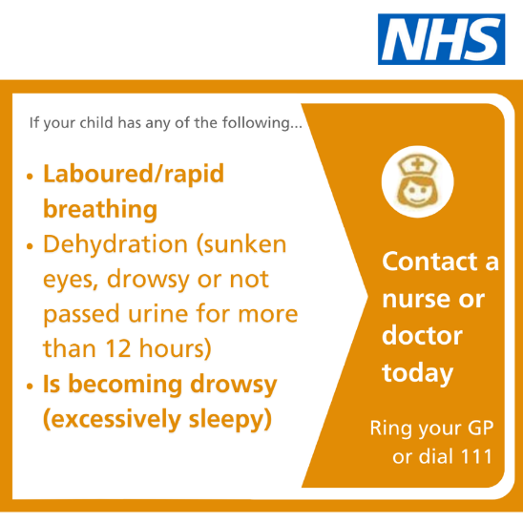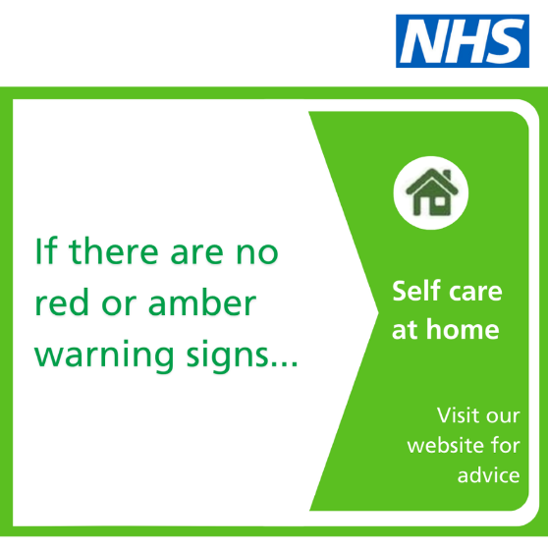

Childhood illness explainer video (from GWH) Link

5 ways to protect your under 5s this winter (carousel)
Using information from UKHSA blog.

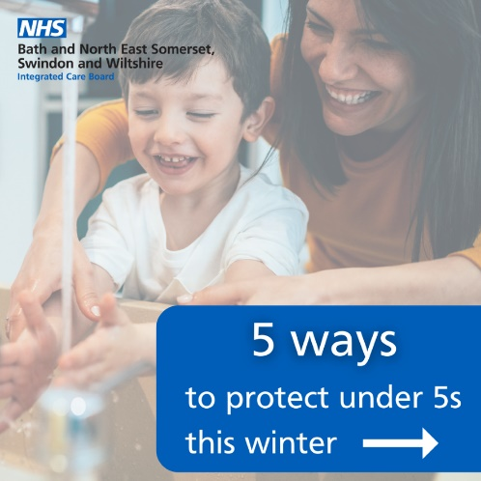

OTHER ASSETS

Video explainer

Childhood illness explainer video (from GWH) Link

Childhood illness – decision tree
Coming soon

All assets

All assets are available to download from the BSW Together Campaigns Page at www.bswtogether.org.uk/yourhealth/campaigns

