Winter flu awareness campaign
 | Copy | Asset
Looking after yourself | There are plenty of ways you can take care of yourself this winter if you do get a cold and avoiding spreading germs to others.  For more healthcare tips this winter visit: https://bswtogether.org.uk/yourhealth/ | 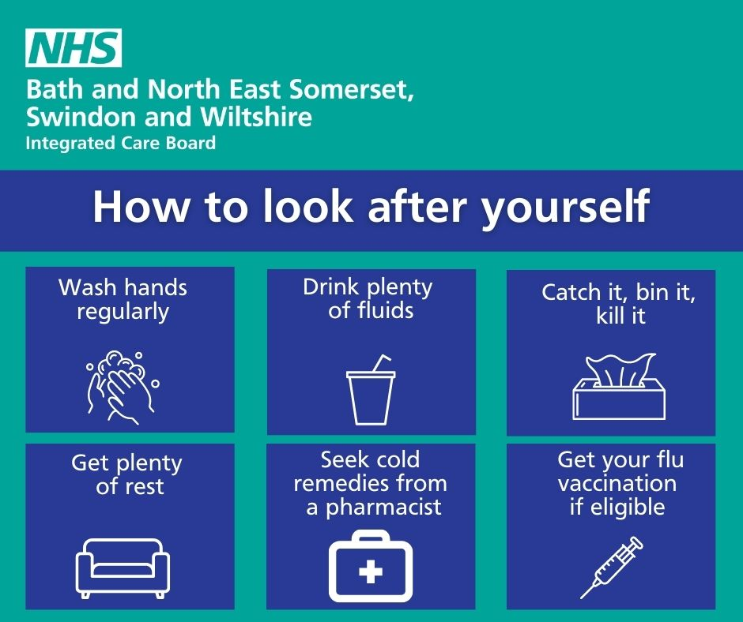
Antibiotics awareness | Did you know?  ✔️Antibiotics can not treat any virus, including the flu.  ✔️Antibiotics are only effective against illness caused by bacteria.  Visit your local pharmacies to find suitable remedies for the common cold and the flu. https://bswtogether.org.uk/yourhealth/pharmacies/ | 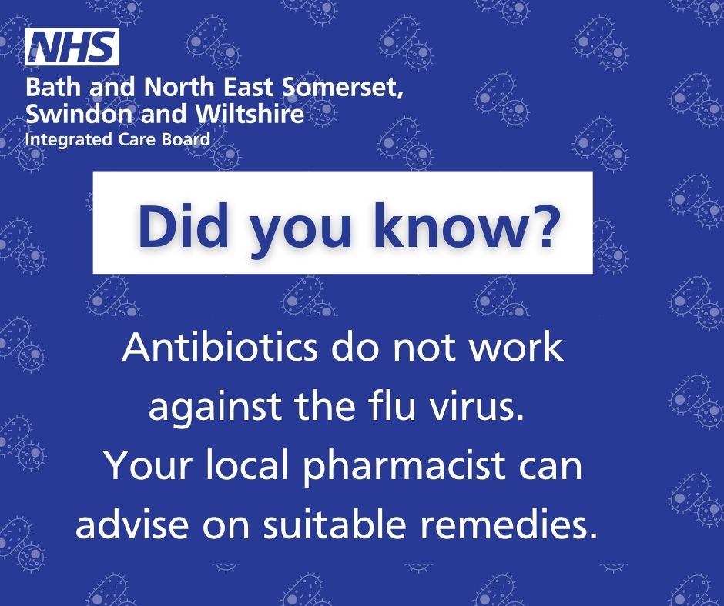
Flu signs and symptoms | People who have the flu often feel some or all of these symptoms suddenly.  If you are sick stay home from work and any social activities.  Most people recover from fever and other symptoms within a week without needing medical attention. However flu can cause severe illness, especially if you are clinically at risk, where you should contact NHS 111 immediately.  More information can be found here: https://www.nhs.uk/conditions/flu/ | 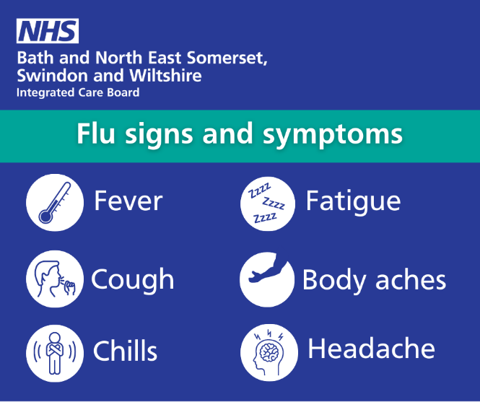
GP advice (talking head video)  Please email for copy to the link | Why are common colds making us feel so much worse than they have done in the past and what can we do about it?  Dr Francis Campbell, Partner Member for Primary Care on the Bath and North East Somerset, Swindon and Wiltshire Integrated Care Board and local GP, explains and talks through some options to feel better. | 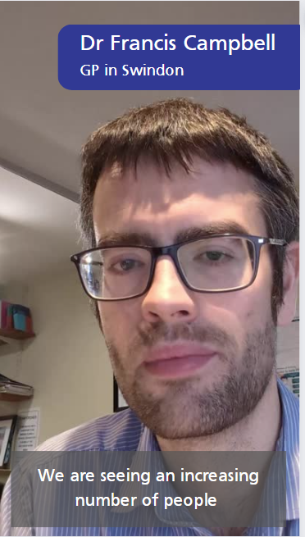
Child - flu | Children can catch and spread flu easily.  The vaccine, which for most children aged 2-3 is a quick and painless spray up the nose is safe and effective.  More information can be found here: https://www.nhs.uk/conditions/vaccinations/child-flu-vaccine/  Vaccines are your best protection against viruses. | 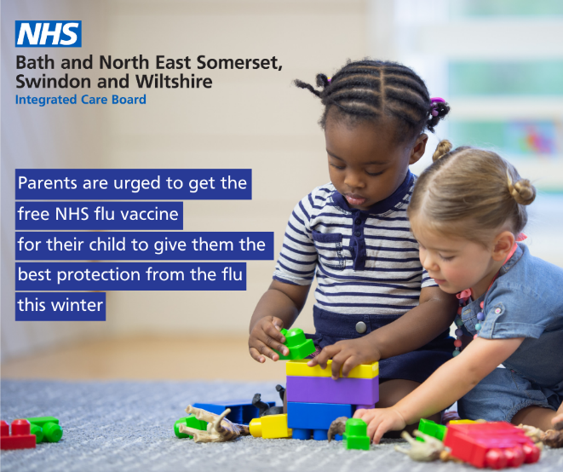
The difference between the flu and a cold | There are some nasty bugs going around this winter, but do you know the difference between a common cold and the flu?  With both conditions, unless you are clinically vulnerable, the advice is not to panic, take it easy and look at self-care options.  More information can be found here: https://www.nhs.uk/conditions/common-cold/ | 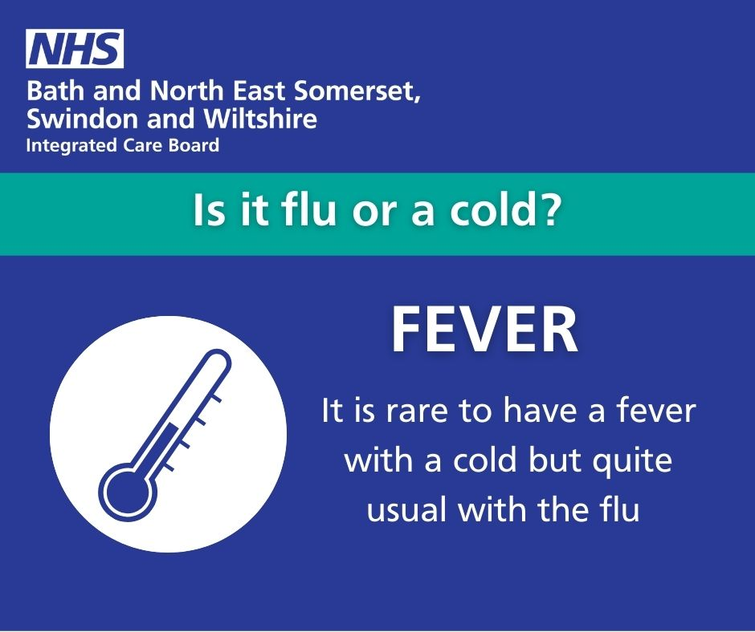  And see below
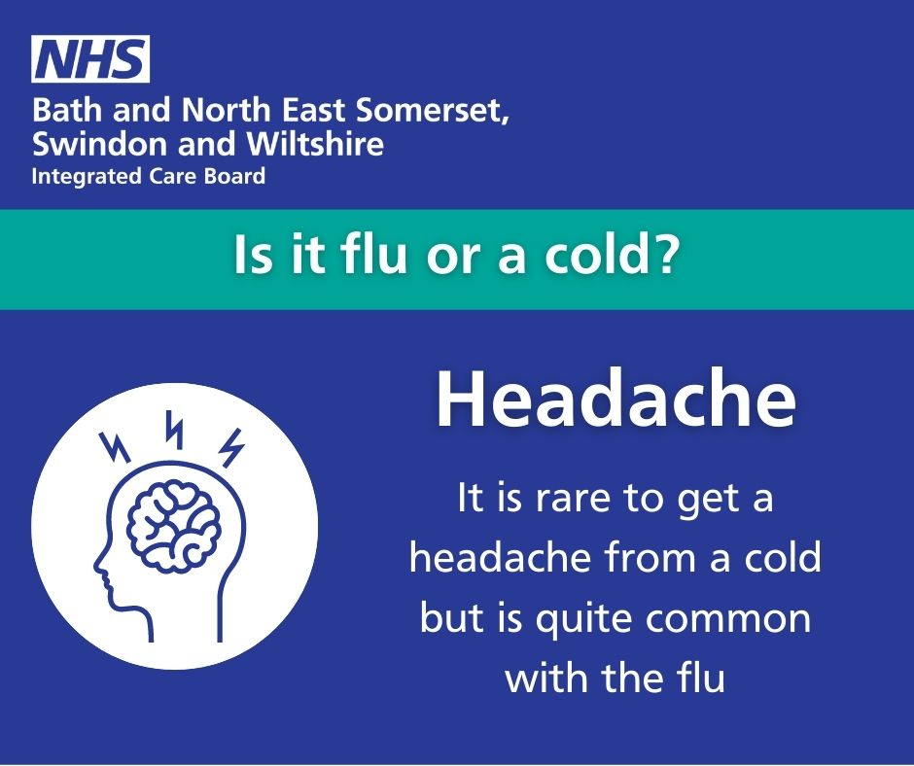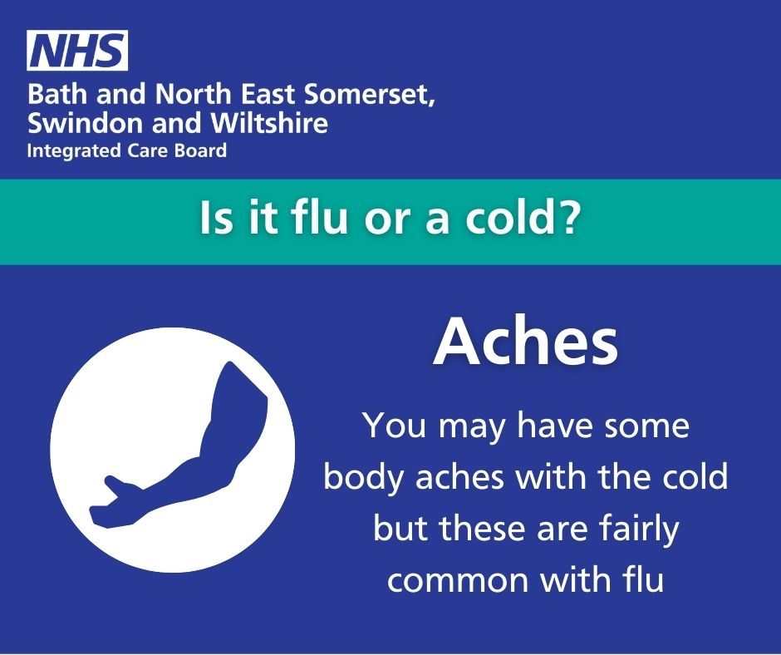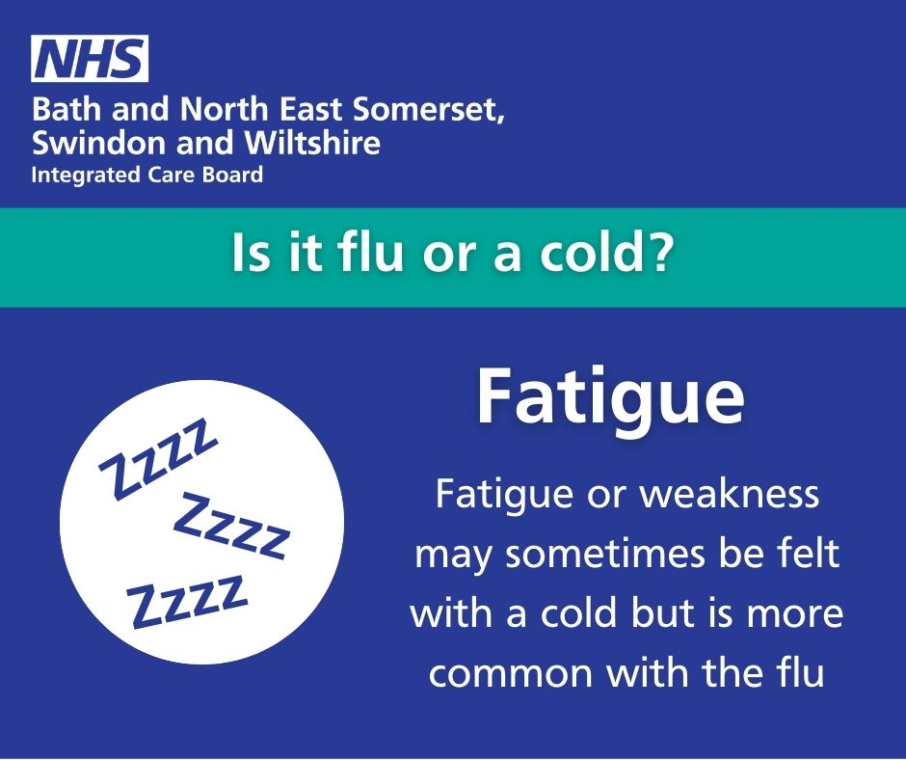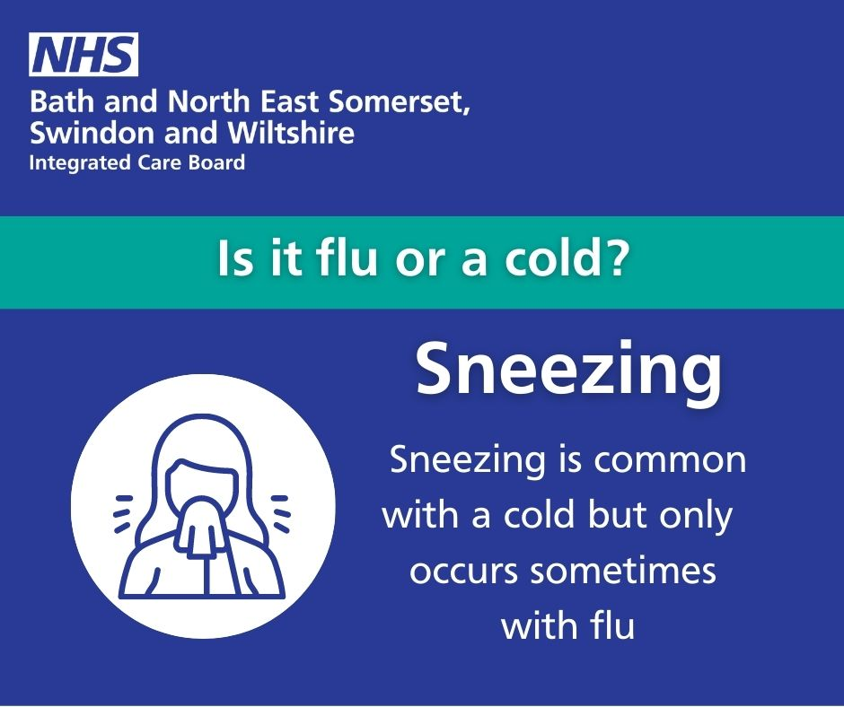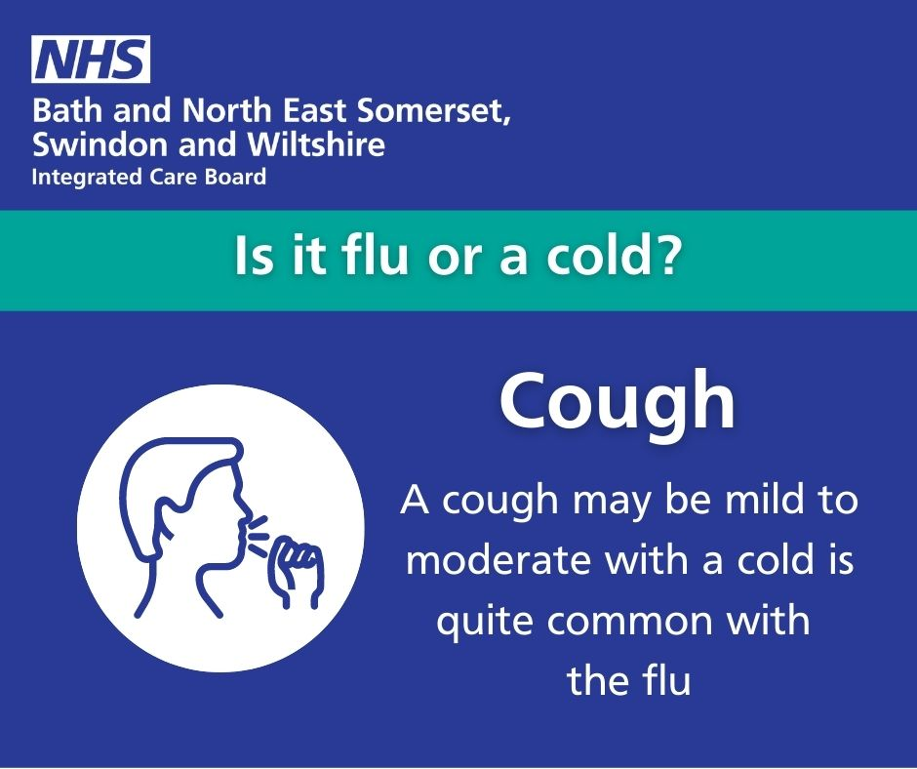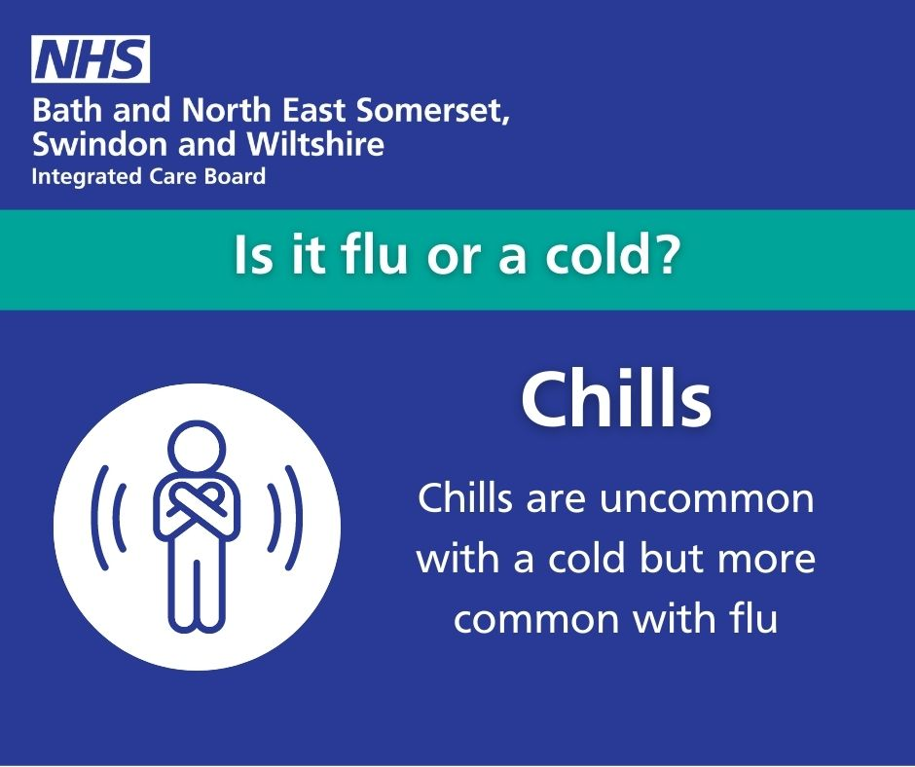
Pharmacist advice | When you have a common cold, unless you are clinically vulnerable, the advice is not to panic.  A pharmacist should be your first port of call if you want to get advice for a cold or flu.  Find your local pharmacist here: https://bswtogether.org.uk/yourhealth/pharmacies/ | 