CYP Toolkit
Suggested Date | Asset | Post copy
Friday 18 July  Start of holidays | 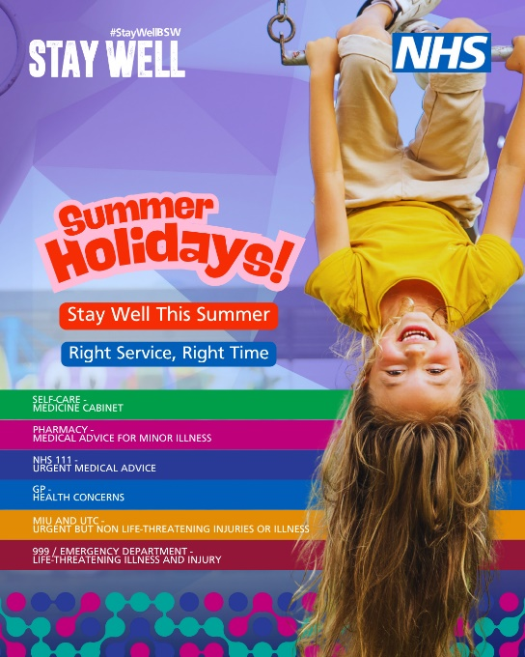 | 🎉The summer holidays are here!  If you or your child is unwell or injured over the holidays you can find local health services here -  https://bsw.icb.nhs.uk/summerholidays/  #StayWellBSW
When appropriate  Hot weather | 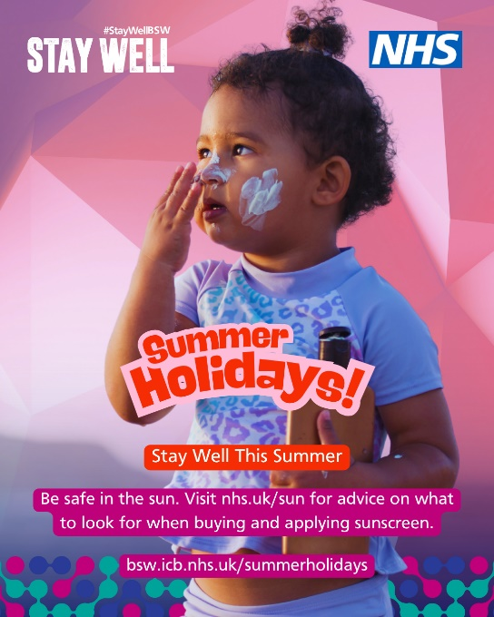 | 😎 Most of us welcome hot weather, but when it's too hot, there are health risks.  In the hot weather remember to...  💧 drink lots of water  🧴 Use at least factor 30 sunscreen  🥵 avoid overheating  ⚠️ be alert for heat exhaustion and heatstroke  https://bsw.icb.nhs.uk/summerholidays/  #StayWellBSW
When appropriate  Hot weather | 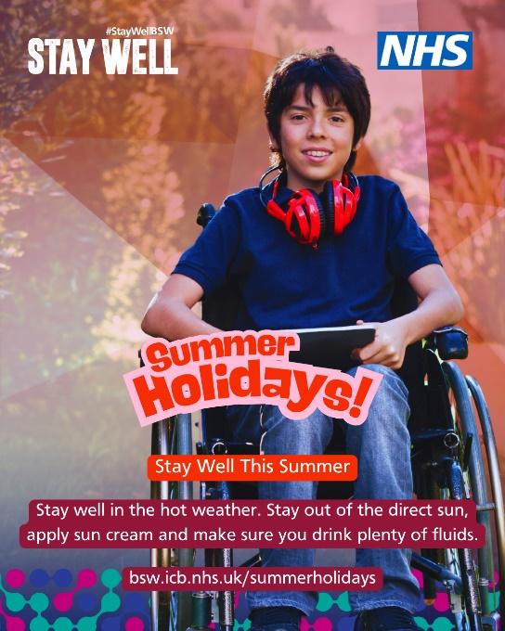 | 😎 Most of us welcome hot weather, but when it's too hot, there are health risks.  In the hot weather remember to...  💧 drink lots of water  🧴 Use at least factor 30 sunscreen  🥵 avoid overheating  ⚠️ be alert for heat exhaustion and heatstroke  https://bsw.icb.nhs.uk/summerholidays/  #StayWellBSW
When appropriate  Pharmacy | 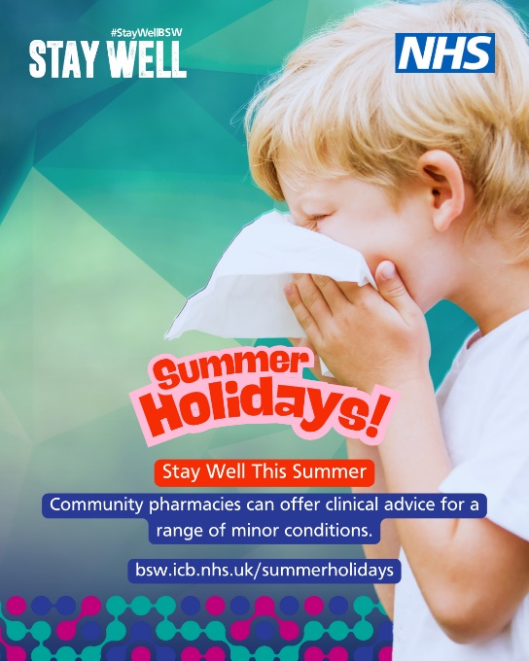 | 💊Visit your local pharmacy for clinical advice on minor health concerns.  There are lots of conditions that are either self-limiting or suitable for self-care that a pharmacist can help with.  https://bsw.icb.nhs.uk/summerholidays/  #StayWellBSW
W/C 11/08/25  ALevel Results | 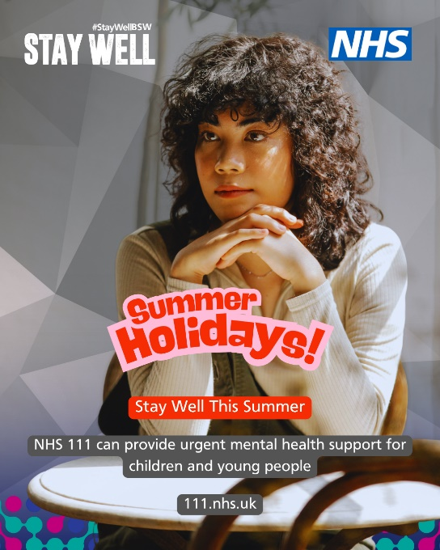 | 🖤 Waiting for exam results can be extremely stressful.  The pressure of ‘good results’ is something which severely worries young minds.  We wish everyone good luck on results day but if you don’t receive the grades you expected, do not beat yourself up, your grades do not and never will define your worth.  nhs.uk/111  #StayWellClassof2025
w/C 18/08/25  GCSE Results | 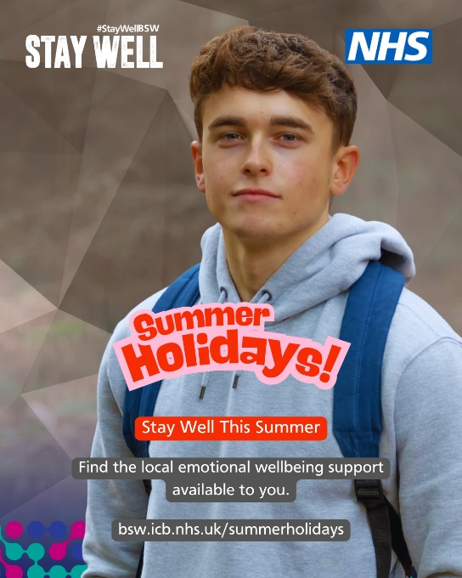 | 🖤 Waiting for exam results can be extremely stressful.  The pressure of ‘good results’ is something which severely worries young minds.  We wish everyone good luck on results day but if you don’t receive the grades you expected, do not beat yourself up, you are so much more than your grades.  https://bsw.icb.nhs.uk/summerholidays/  #StayWellClassof2025
When appropriate  Hot weather | 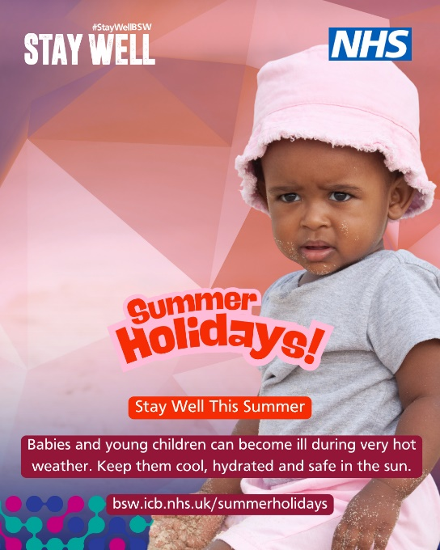 | 👶 It is important to keep your baby safe and comfortable in the hot weather.  For tips and advice visit https://bsw.icb.nhs.uk/summerholidays/  #StayWellBSW
When appropriate  Hot weather | 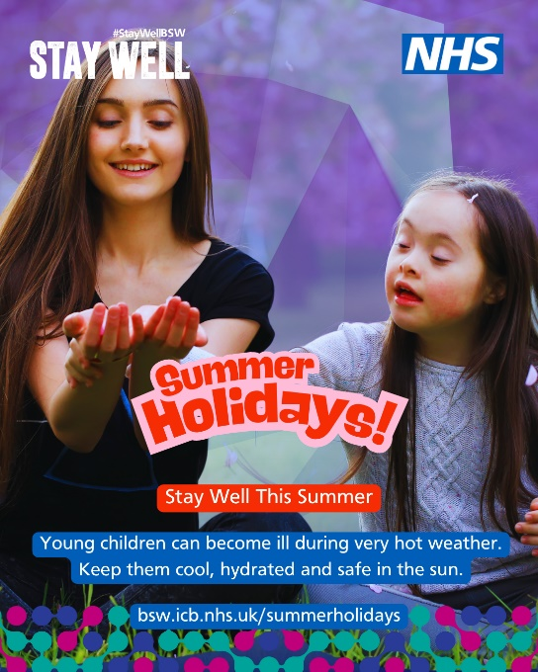 | ☀️ It is important to keep young people safe in the hot weather.  For tips and advice visit https://bsw.icb.nhs.uk/summerholidays/  #StayWellBSW
W/C 25/08/25  Back to school ready | 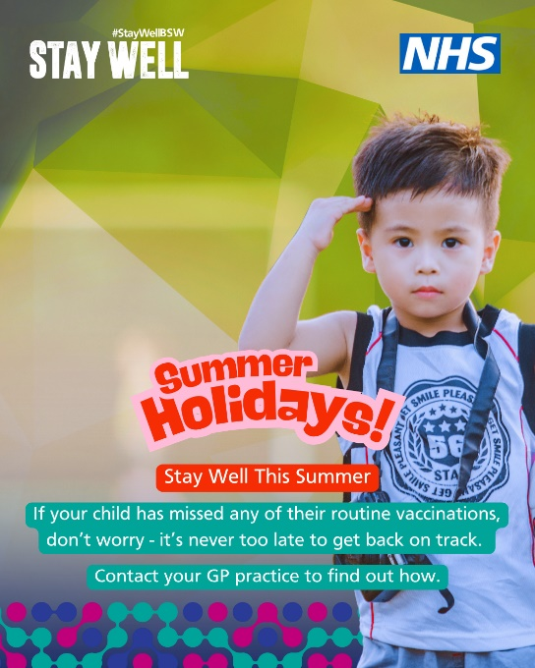 | 📝 Are you ‘Back to School’ ready?  If your child has missed any of their routine vaccinations, don’t worry - it’s never too late to get back on track. Vaccines can be safely given at any time, and your child doesn’t need to start the schedule over. They can simply pick up from where they left off.  Staying up to date with vaccinations helps protect your child and those around them from serious illnesses.  Contact your GP practice to arrange a catch-up appointment.
W/C 01/09/25  Right service, right time | 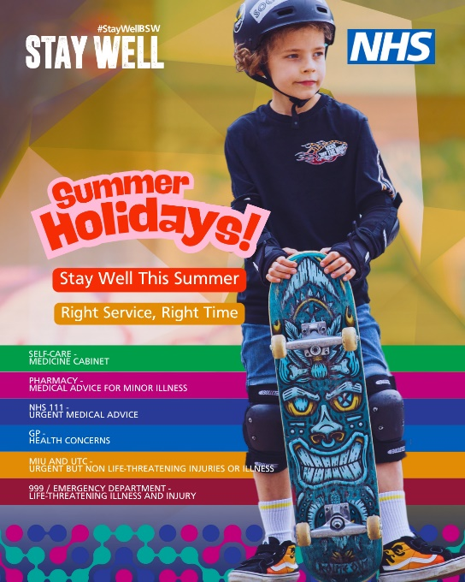 | Unwell or injured?  Get to the right service at the right time.  https://bsw.icb.nhs.uk/summerholidays/  #StayWellBSW

